**HETHERSETT ACADEMY**

**Calculation Policy January 2015**

**Written by the Hethersett Cluster**

With grateful thanks to Woodside Infant, Mulbarton Infant and Junior, Hethersett Junior, Cringleford Primary and Little Melton Primary and Hethersett Academy whose continued collaboration has made this document possible.

**Introduction**

This calculation policy presents the calculation strategies which have been taught in the feeder primary schools and therefore those to be used and consolidated in Hethersett Academy. The policy contains some additional methods to formalise and extend the previous methods which may have been used by our students on their calculations journey.

**Main aims:**

* To ensure that the calculation methods used are based on sound educational research and practice, enabling children to make connections between different operations and understand the calculations they carry out, leading to correct answers.
* To ensure that the calculation methods are taught consistently across the pyramid, leading to good or outstanding progress in the children’s learning.
* To ensure that parents and carers can support their children out of school, minimising confusion and creating better ‘number sense’ in their children.

This should be evidenced in lessons developmentally by :-

* children showing engagement when working with numbers
* an ability to discuss or explain how they are solving a calculation
* progressing to show an ability to teach the process to another pupil or adult

applying the processes to a range of more challenging calculations, including those using decimals.

When a child comes across a calculation they will be encouraged to always follow these steps:

1) Can I do this in my head?

2) Can I do this in my head but need to jot something down to help me?

3) Do I need a full written method for this?

4) Do I need a calculator for this?

All of this should develop a child’s ‘Number Sense’.

[](http://www.google.co.uk/imgres?q=addition+symbol&safe=active&sa=X&hl=en&biw=1024&bih=559&tbm=isch&tbnid=ki_h-fUdo6QkbM:&imgrefurl=http://www.onlinemathlearning.com/grade-1.html&docid=L_dPjbFJ0ZgBqM&imgurl=http://www.onlinemathlearning.com/image-files/addition.gif&w=491&h=490&ei=XlpxUfCnBYKmhAf6sYHIBQ&zoom=1&iact=hc&vpx=111&vpy=185&dur=1170&hovh=224&hovw=225&tx=136&ty=107&page=3&tbnh=141&tbnw=141&start=43&ndsp=27&ved=1t:429,r:44,)**ADDITION**

**Key Words**:

add, addition, total, plus, more than, and, altogether, increase, sum etc.

**Aggregation/Gathering Together**

The concept of addition is that when we add two or more quantities/amounts together we are calculating how much there is altogether: we are aggregating the quantities. Children gradually move from the concrete to the representational to the abstract by such prompts as:

* “How many altogether?” resulting in the counting and or counting on of concrete objects or representations of concrete objects

Leading to the abstract:

* “What is the total?” For example: What is the total of 23 and 38?

**Augmentation/Increasing**

Augmentation is the idea that a quantity is increased by another quantity. This concept is well described by use of a representational number line. Looking at 23+38 The focus of the problem starts at 23 and this is increased by moving an 38 more.

**How will children represent their calculations on paper/White board?**

**1) Empty number line**

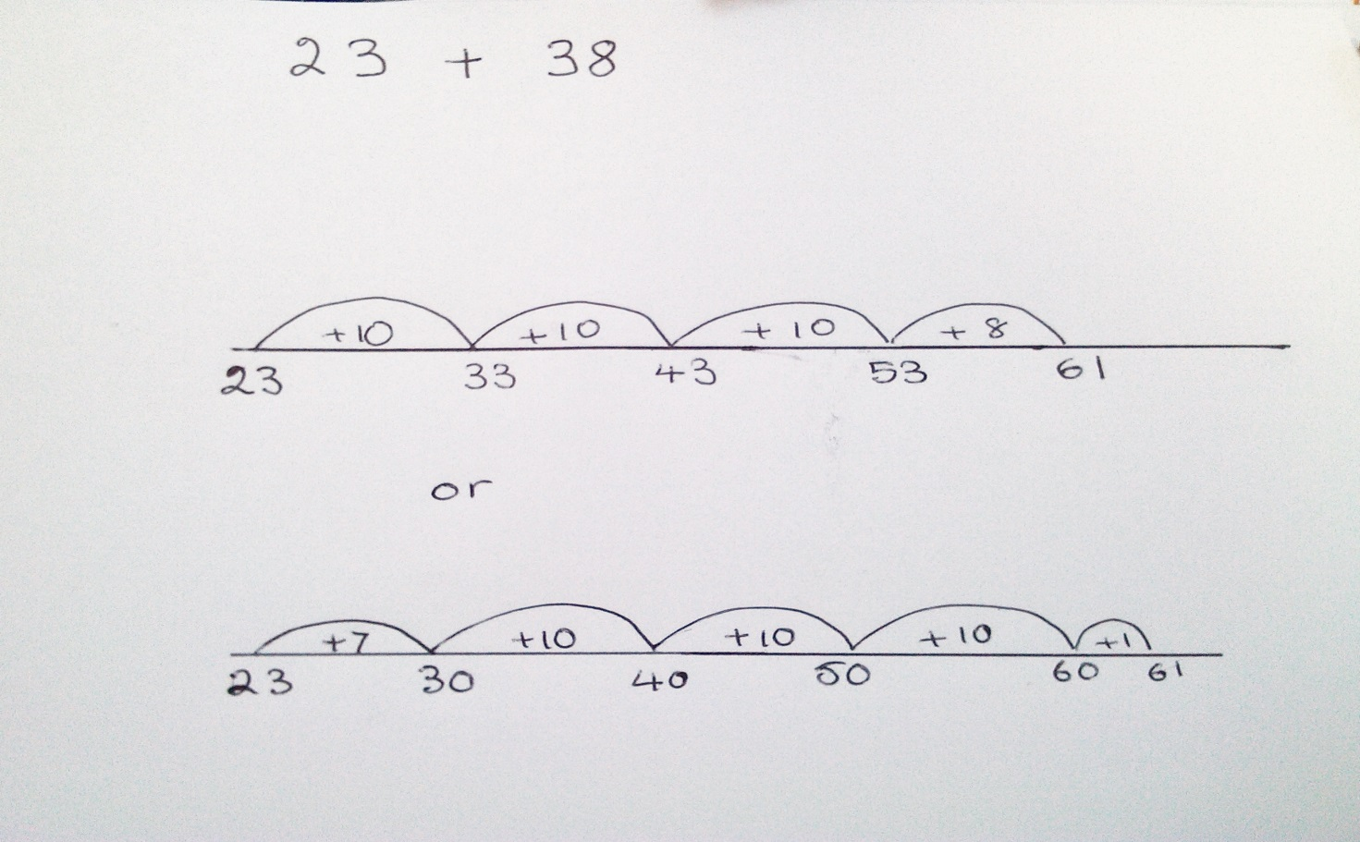

When departing from true representations of a concrete reality a Singapore Bar may be useful to children to visualise the problem.



**2) Partitioning Numbers** 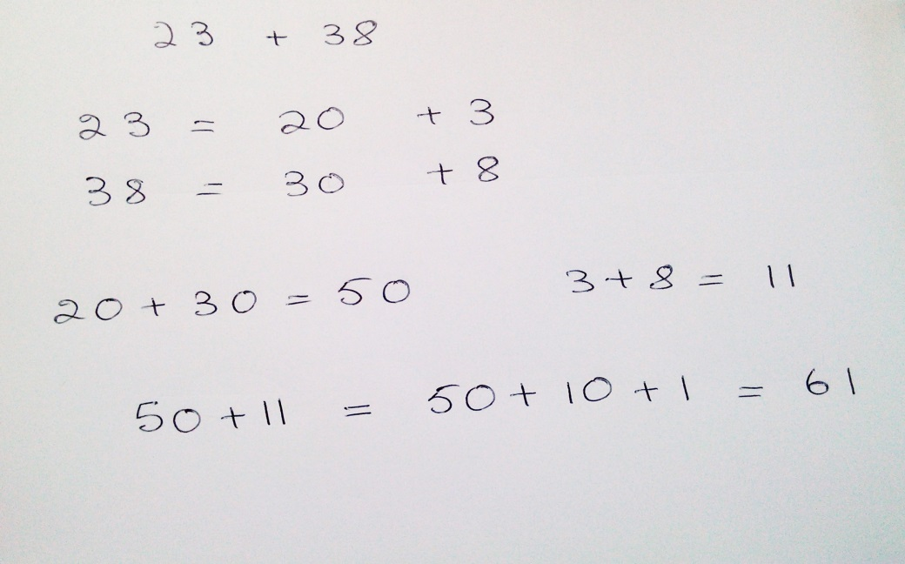

**3) Expanded Column Method**

Although only in digits with no representational bar this method in columns this method remains more representational of the quantities involved and their possible partitioning

Note: what does the above mean?

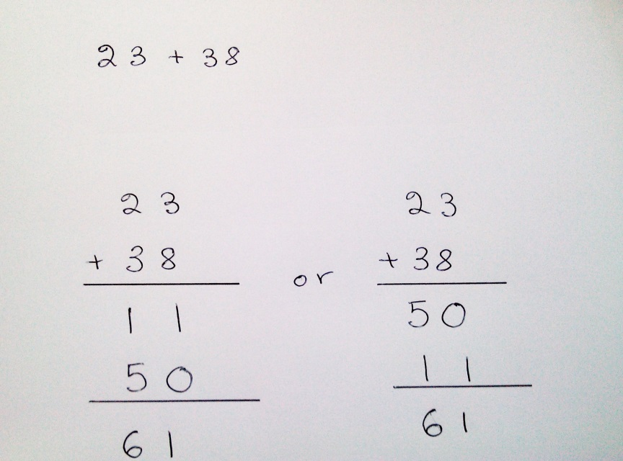

**4)Formal Column Method**

First add the units then the tens etc. The emphasis on starting on the units side makes this method fundamentally different from the expanded column method as it is now totally abstract and removed from the partitioned number.

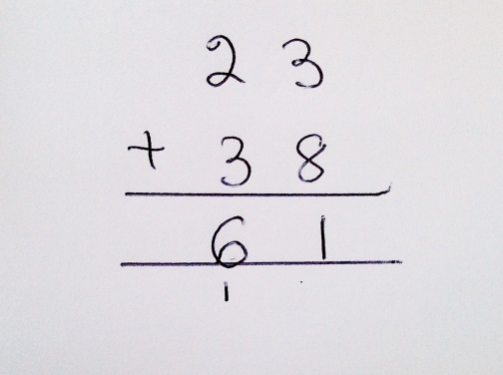

[](http://www.google.co.uk/imgres?q=subtraction+symbol&safe=active&hl=en&biw=1024&bih=559&tbm=isch&tbnid=Usl8zaIHtYI4gM:&imgrefurl=http://www.sd104.s-cook.k12.il.us/students/math/JoseMelara/josesmath.htm&docid=FOZxrWQ4xe7FnM&imgurl=http://www.sd104.s-cook.k12.il.us/students/math/JoseMelara/Subtraction_small.gif&w=100&h=96&ei=plpxUbLMEM6BhQfC3YCgDw&zoom=1&iact=rc&dur=374&page=4&tbnh=78&tbnw=81&start=70&ndsp=23&ved=1t:429,r:70,s:0,i:295&tx)**SUBTRACTION**

**Key Words:**

subtract, subtraction, take away, minus, less than, difference, decrease, leave, how many left etc.

The subtraction calculation may result from a variety of problems leading from the concrete beginnings to the more abstract.

**Partitioning**

Partitioning is a concept used across many areas of calculation including the concrete basis of subtraction. “There are 7 pens 3 are taken away how many pens remain?” The 7 pens are broken up into a 3 leaving a 4 ‘part’ .

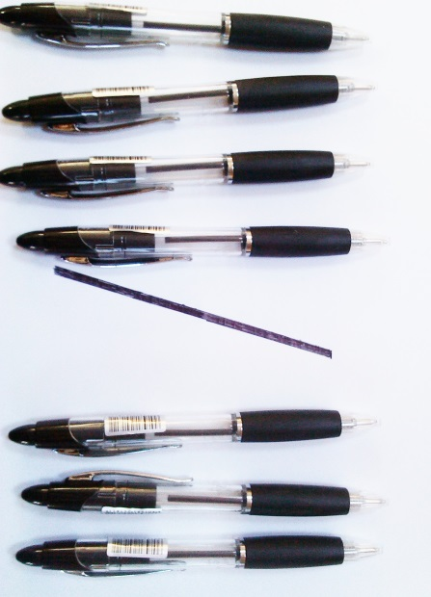

**Reducing**

Subtraction may also be conceptually reduction. If 7 is reduced by 3 then 4 remains. This is the inverse of the increase. A number line is again very representational allowing the initial focus to be the number from which we are subtracting.

**Finding the difference/ Comparing two numbers or quantities**

When children can cope with finding the difference between two quantities they are moving to a more abstract calculation which can be applied in far more problems.

**Subtraction as the inverse of addition**

At the most abstract level children learn that these two operations are inverses to each other is “they undo each other”

**How will children represent their calculations on paper/White board?**

**Empty number line**

This method will remain the method of choice for many children throughout their school career as it is representational of the quantities involved.

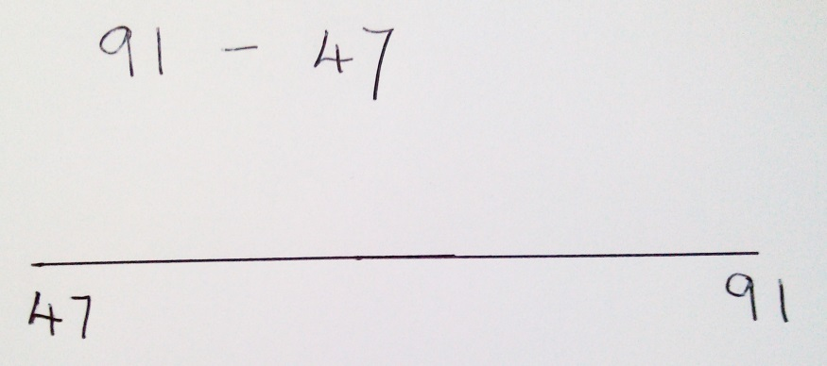

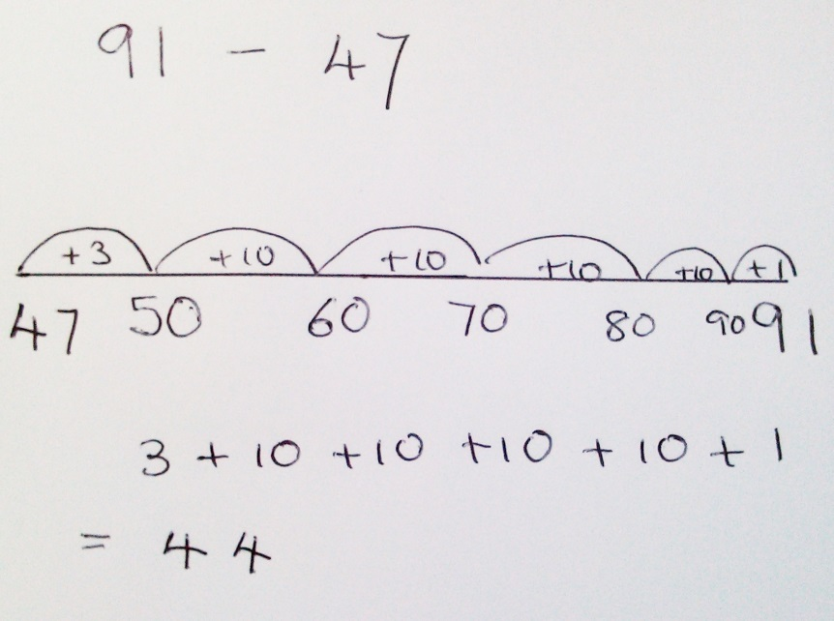

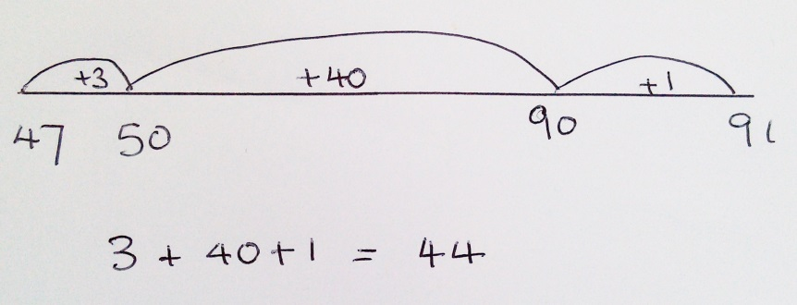

When departing from true representations of a concrete reality a Singapore Bar may be useful to children to visualise the problem.

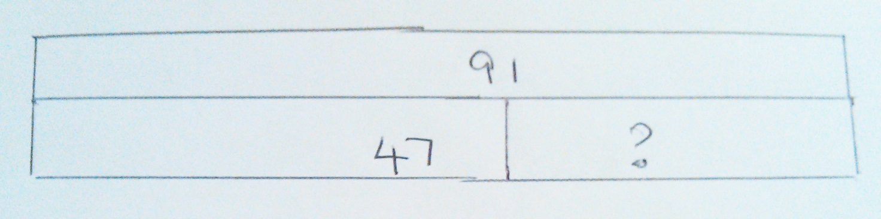

As a bridge between the above methods and formal column subtraction some pupils may find the number line calculations without the number line to be an appropriate bridging step.



**Subtracting in columns**

This is the culmination of the subtraction journey, a totally abstract pen and paper method. The regrouping of the number from which we are subtracting is a development of the ideas of portioning and chunking which will already have been developed.

