MULTIPLICATION

Keywords:

multiply, lots of, product, groups of, times, repeated addition etc.

Multiplication may be considered as repeated addition and is usually introduced as such. However, it may also be considered as a scaling up.

Repeated addition

The repeated addition of 3+3+3+3 becomes 4 lots of 3which makes 12

Scaling

Scaling up 3 by a factor of 4 is 12

How will children represent their calculations on paper/White board?

Partitioning and informal recording

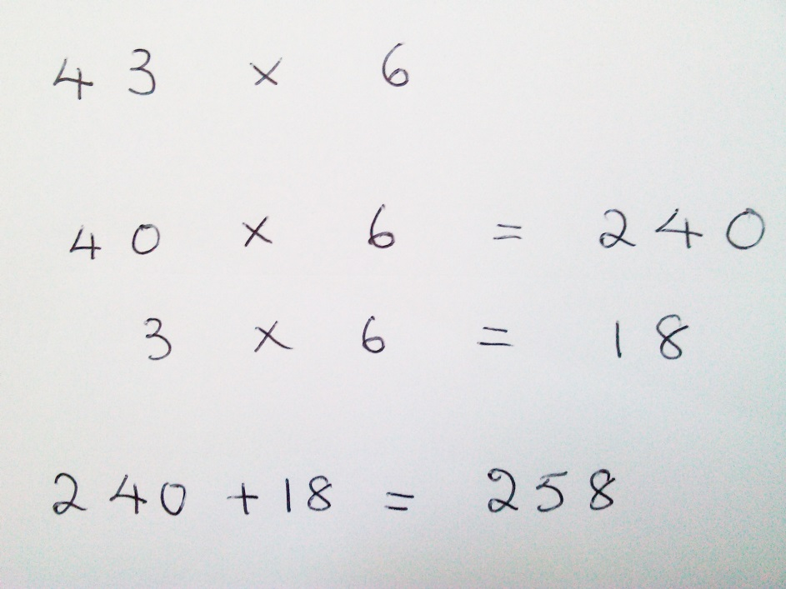

Some students are using the Singapore Arrays which should lead on to the proportional grid method
x |  |  | 6
 | o | o | o | o | o | o
 | o | o | o | o | o | o
 | o | o | o | o | o | o | 60
 | o | o | o | o | o | o
10 | o | o | o | o | o | o
 | o | o | o | o | o | o
 | o | o | o | o | o | o |  | 84
 | o | o | o | o | o | o
 | o | o | o | o | o | o
 | o | o | o | o | o | o
4 | o | o | o | o | o | o
 | o | o | o | o | o | o | 24
 | o | o | o | o | o | o
 | o | o | o | o | o | o

x | 6
10
 | 60
 |  | 84
4 | 24

The proportions of the ‘sections of the array’ are crucial to keeping the representational value of this method.

When departing from true representations of a concrete reality a Singapore Bar may be useful to children to visualise the problem.

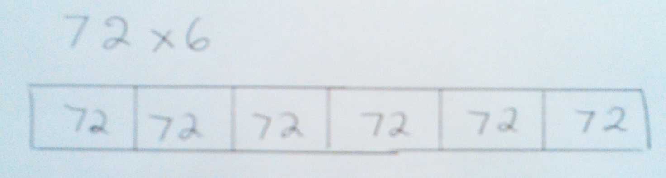

Grid method (formal/abstract)

x | 90 | 8
200 | 18000 | 1600
40 | 3600 | 320
7 | 630 | 56
 |  | 24206

This is now completely abstract and removed from either concrete or representational.

When completing decimal multiplication by the formal grid method, students should be encouraged to ignore the decimal point and reinsert afterwards according to the rule of the number of digits in the question gives the number of digits in the answer.

Napier’s Bones Multiplication

A very few children learn this method from outside school and use it successfully, however, research has shown that in general children who use it are less successful.

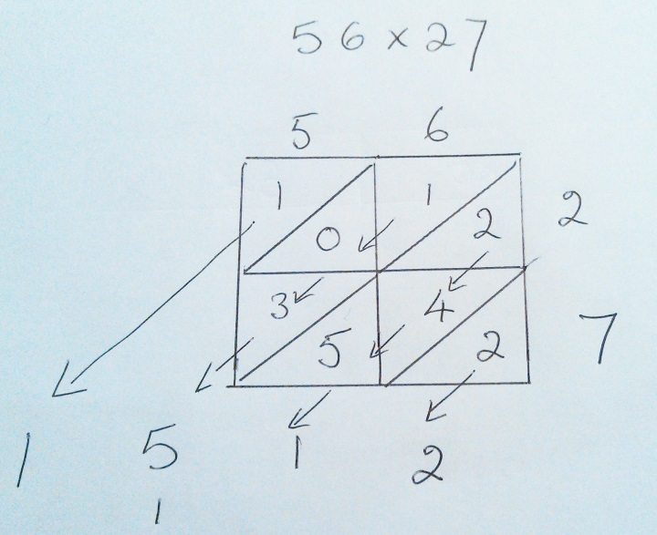

Formal Column Method

This is totally abstract and many school students will never adopt this method staying successfully with the very transparent and representational grid method.

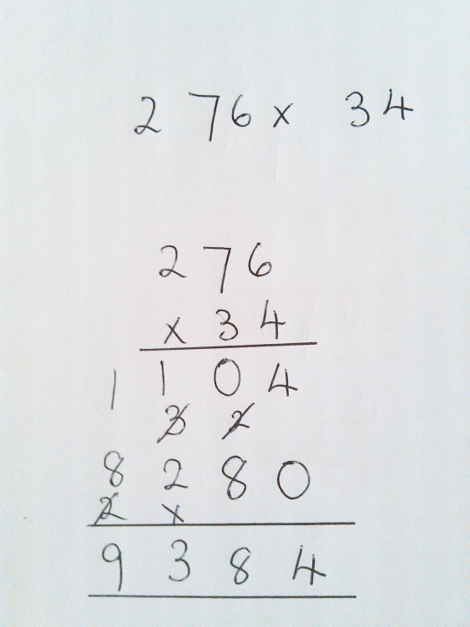

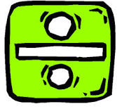
DIVISION

Keywords:

divide, division, divided by, share, sharing, equal, equally, how many, remainder, quotient, divisor, dividend etc.

Division arises from equal-sharing, this eventually leads to it being the inverse of multiplication structure and then to ratio.

Equal sharing

We could share 28 into 4 equal groups each of 7 ie 28÷4=7 This is usually the first introduction of division to the children

The inverse grouping of multiplication

Considering the same problem differently (another example of a form of partitioning of a number) how many groups of, or lots of, 4, are there in 28? This is the same 28÷4=7 Children need to learn the inverse relationship of the two statements.

How will children represent their calculations on paper/White board?

The number line
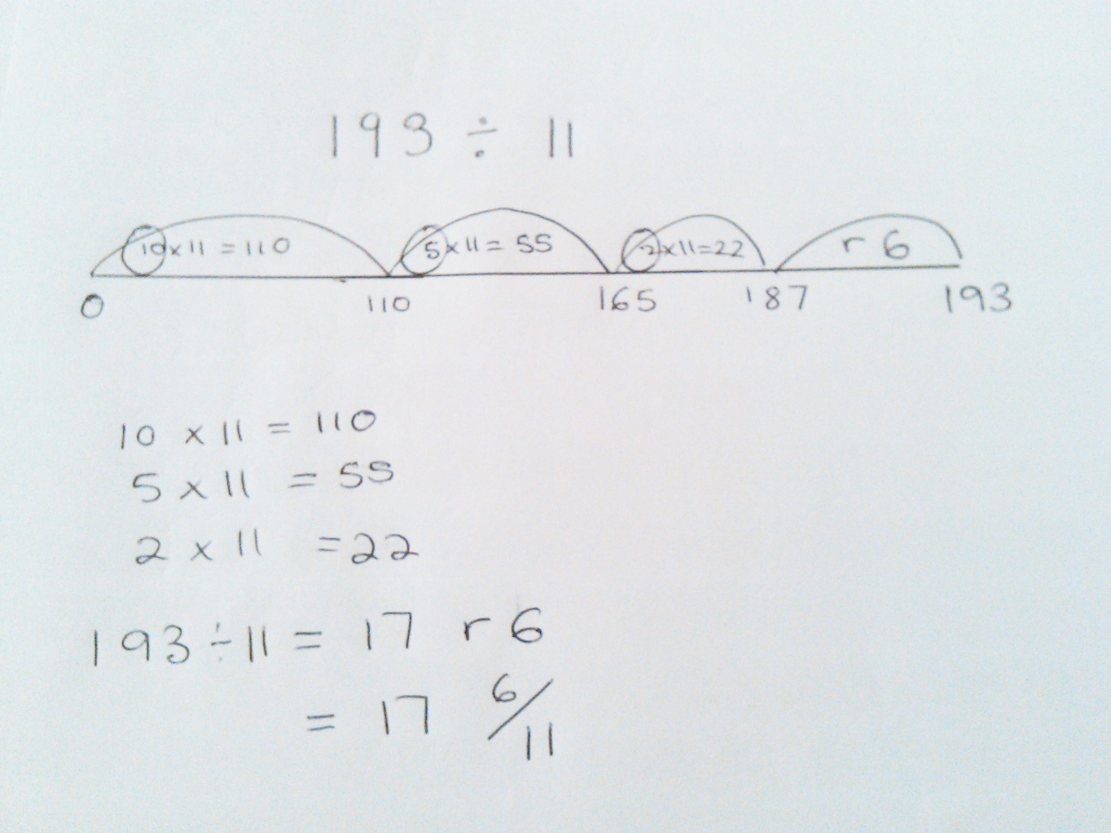

For decimal division this level of representation becomes very difficult. Hence if a child is at a level to be learning division by decimals then they should already be at a higher level of abstraction of calculation.

Chunking

Division calculated by repeated subtraction can be shortened by chunking whilst still keeping some representational elements. Eg
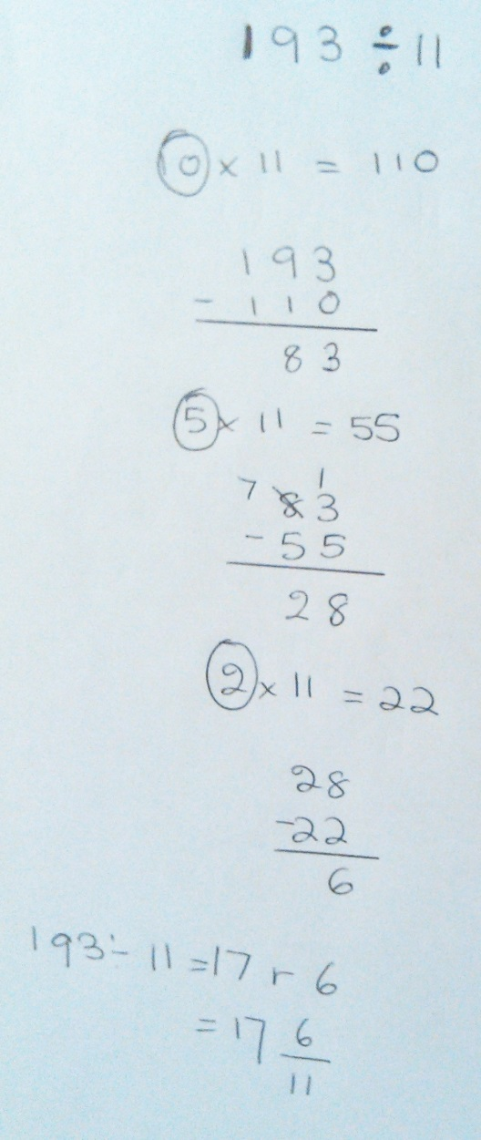
Use of a Singapore bar can often provide a representational element to a more complex problem (even one which demands a more complex calculation)
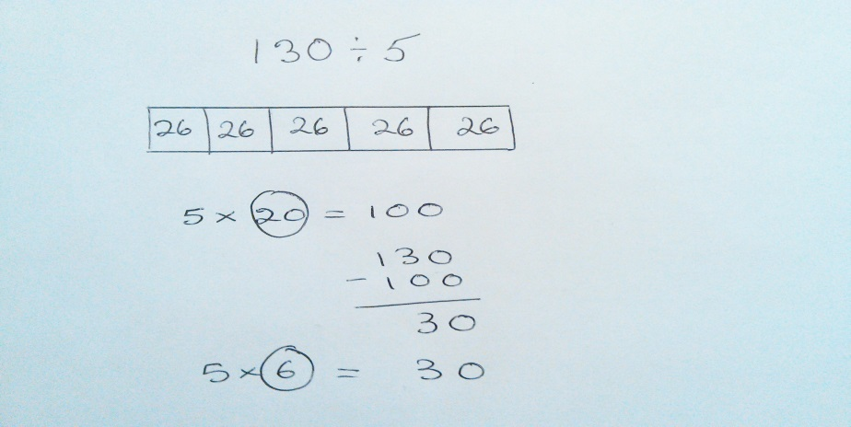
When the children really understand these expanded methods they can be shown how they are developed into a compact method. Remember though that the expanded methods are perfectly good ways of working out an answer if the children feel more comfortable and therefore find it easier. They give the same answer and it can often be quicker if they are confident about what they are doing.

Short / long division
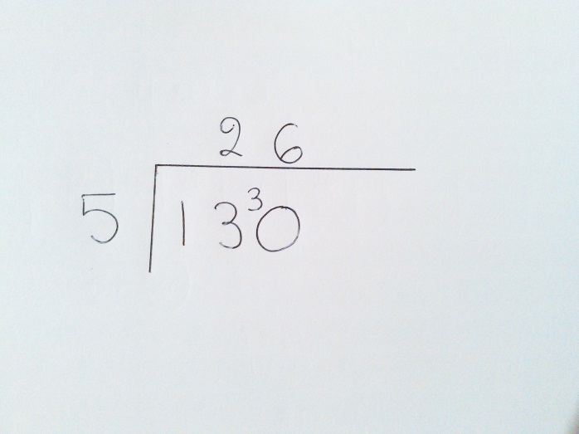
When completing decimal division the above method is very advantageous. There is, however, no need for long division at GCSE at the present time.

However, a balance must be sought for able students between transparency of method, ie its representational value and the efficiency of the method given the time constraints of examinations
