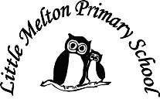
Real-life Maths:
Links to Science/Geography
Time

Extended Writing
1 Art and design: instructions/ recipes
2 Science: explanation text
3 English: stories with action
4 Life in Viking times
Keeping Safe and Healthy:
ICT: on line safety
DT: Bread Making and design

Assembly Themes & Special Days:
See assembly list
British Values
Harvest

P.E.
Swimming
Football
Netball
Ball Skills

Music
Dragon music – Puff the Magic Dragon
Guitar/Ukulele/Recorders/Keyboard?
What is a Staff
Notes in Treble and Bass Clef
Famous Composers (BBC TEN PIECES)

English:
Class read- How to Train Your Dragon

Grammar & Punctuation:
Full stops, capital letters, colons & semi colons in detailed lists.
Full speech punctuation
Commas to mark clauses
Short sentences for effect

Writing:
Writing our own action packed Dragon stories

Guided Reading:
Love of reading: Dragon poems/stories

Spelling: Spellzoo scheme

Big Writing Genres:
Writing short action scenes for stories.
Instructions

Class: Eagle Owls Year Group: 5/6
Term: Autumn 1st Half
Cycle: A
Let there be Dragons
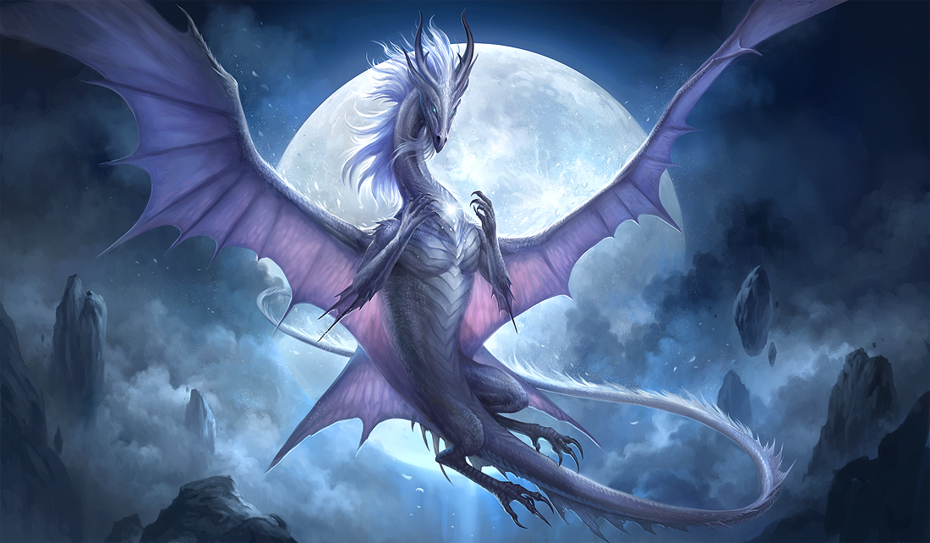
Art & Design
Food Tech – Bread making

Computing
e-safety
Communication
Research
Powerpoint/slide manipulation
VLE
Humanities TOPIC
British History leading to the Anglo-Saxons and Viking invasions/impact on Britain
Mathematics:
Including: TARGETS
Multiplication and division by 10 100 1000
Place Value
Roman Numerals
Addition and Subtraction
Shape
Algebra

Science:
Properties and Changes of Materials

