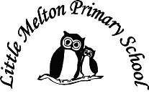
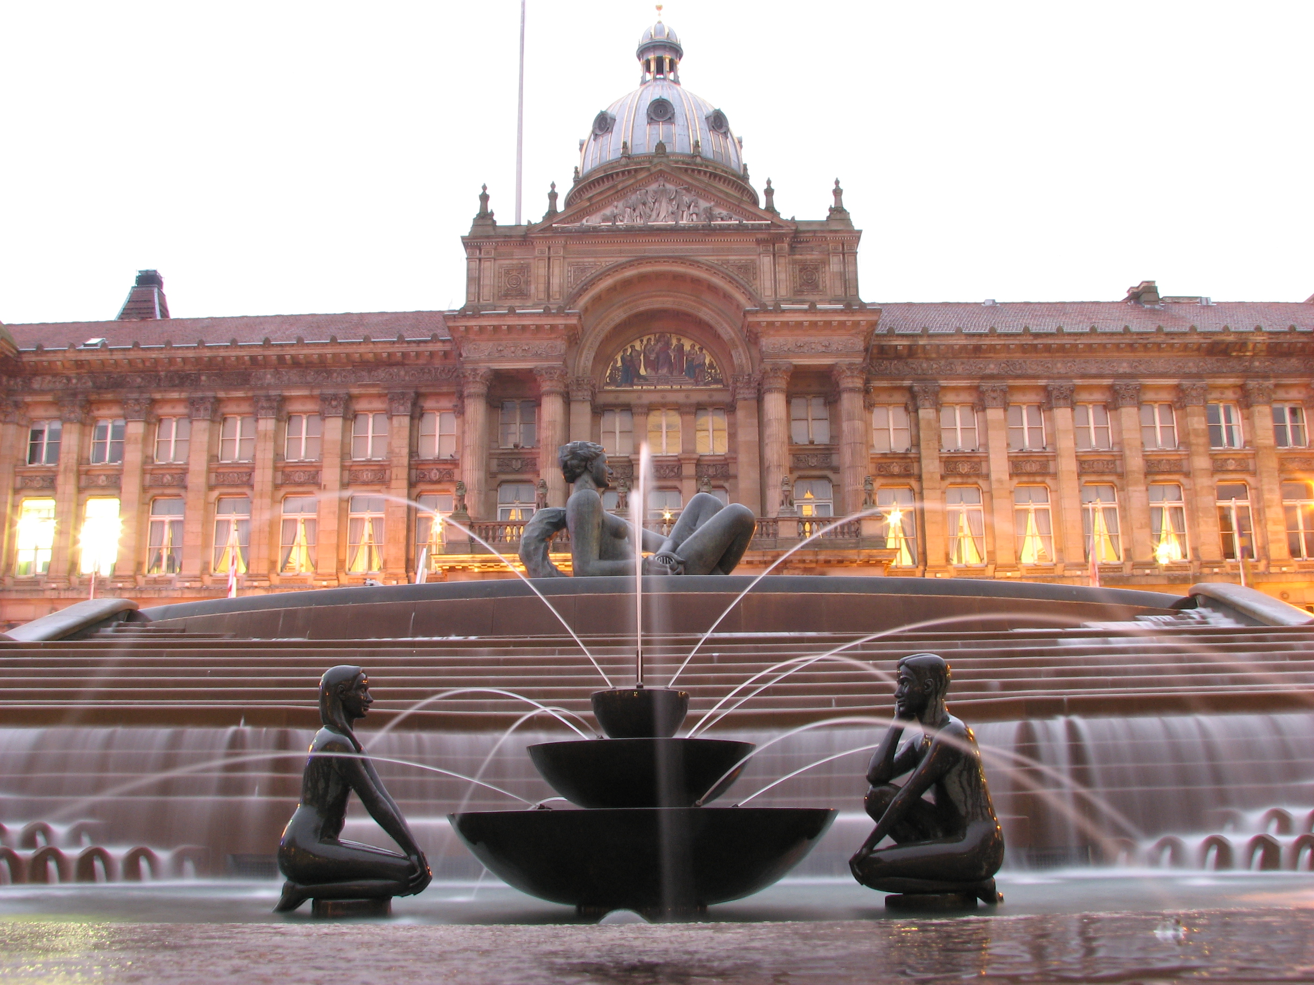
Real-life Maths:
Links to Science/Geography

Extended Writing
1 Art and design/Science: Evolution and Inheritance based on Animalium
2 Science: explanation text
3 RE The story of Passover
4 Travel Brochure
Keeping Safe and Healthy:
ICT: on line safety

Assembly Themes & Special Days:
See assembly list
British Values

RE: The Ten Commandments (Christianity)
P.E.
Swimming?
Gymnastics
Dance
OAA -PGL Residential Experience
Music
Performance - learn to sing and use their voices (collaboration with NS)
Listen – to evaluate music including the works of great composers and musicians (Ten Pieces cont’d)
English:
Class read-Journey to the River Sea

Grammar & Punctuation:
Active and passive sentences
Revision of all grammar and punctuation

Writing:
Letters to authors
Discussion and persuasive text

Guided Reading:
Journey to the River Sea

Spelling: Spellzoo scheme

Big Writing Genres:
Letters/ persuasive/ argument/travel brochure

* content of Topic will vary each half-term, different subjects may be taught discretely, also may not always have every subject each half-term– just need to cover altogether
Class: Eagle Owls Year Group: 5/6 Term: Spring Cycle: B
It’s a small world
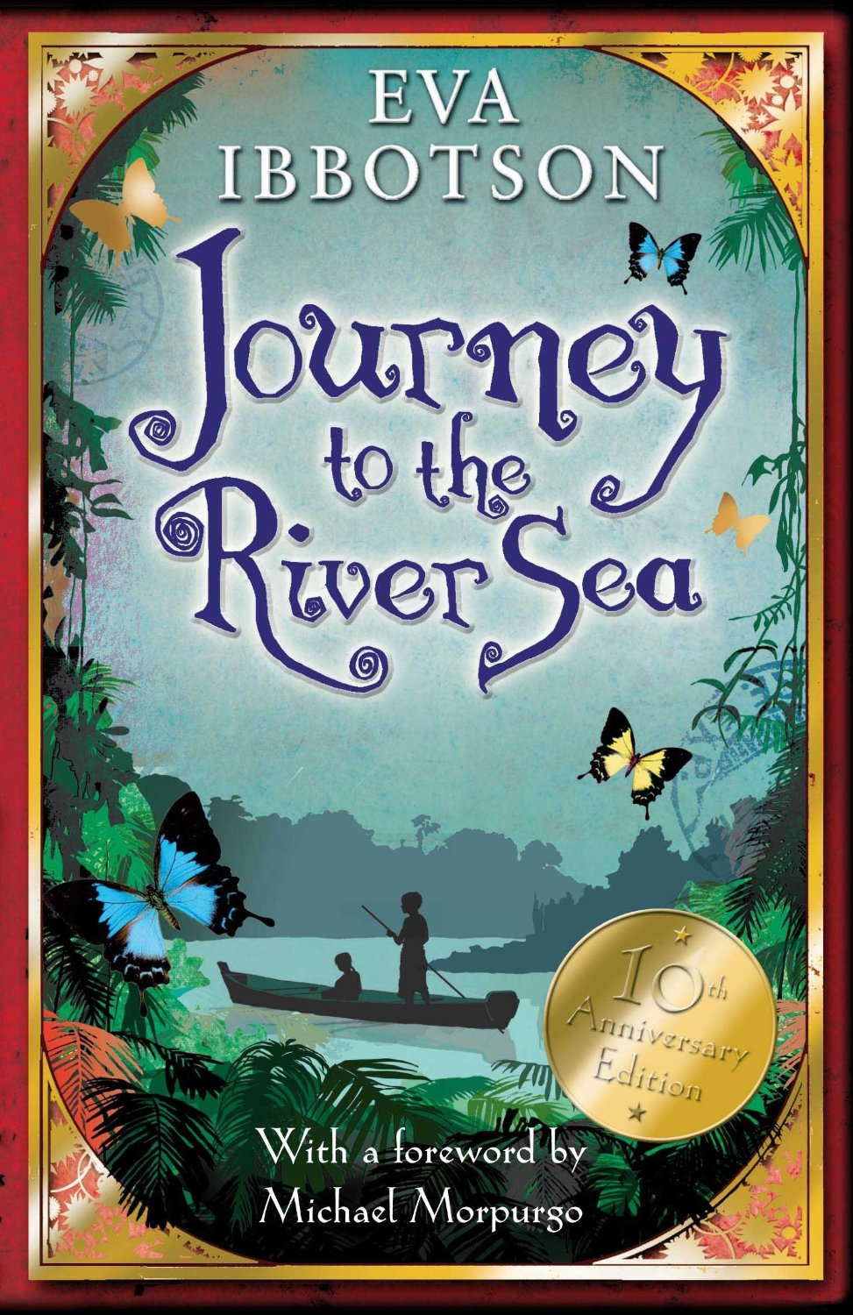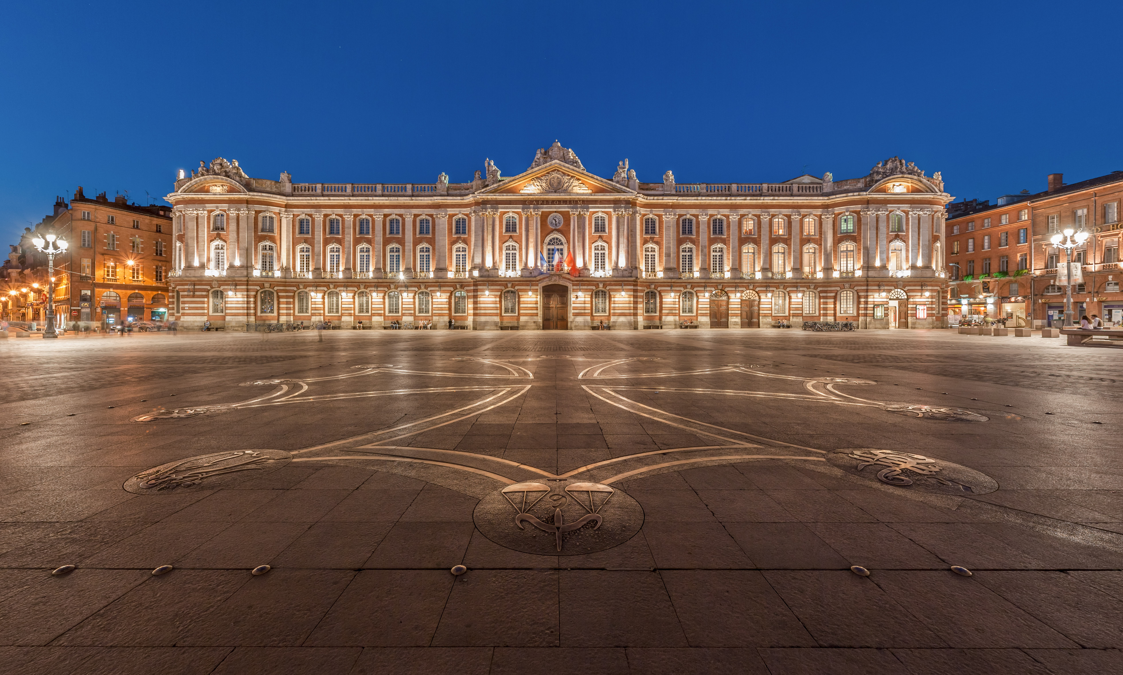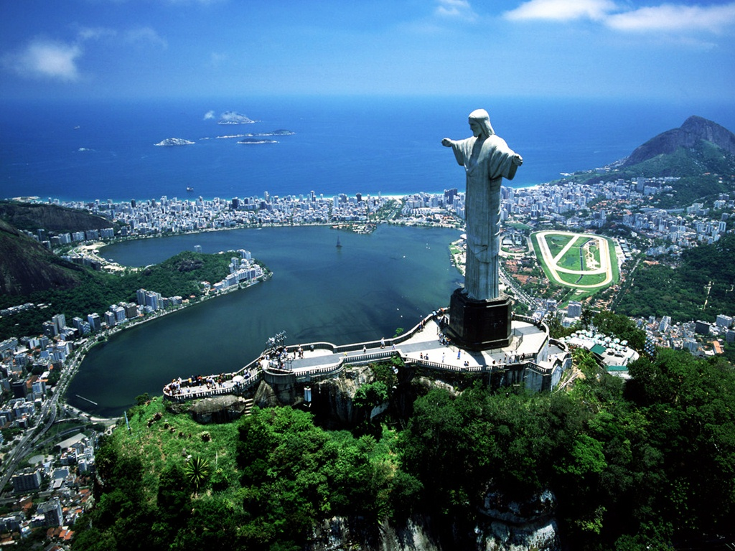
Art & Design
Animalium
Animal portraits using water colours
Computing
e-safety
Communication
Research
Powerpoint/slide manipulation
VLE
Humanities TOPIC – Geography based
Human and Physical geography of 3 places: Toulouse/Birmingham/Rio de Janeiro
Mathematics:
Including: TARGETS
Roman Numerals
Addition and Subtraction of fractions
Long division
Shape – area/perimeter and volume
Basic Algebra
Standard written methods of all operations

Science: Evolution and Inheritance
Animals – including humans
Linked to Art (Animalium – text)

