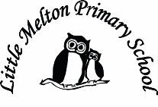

**English:**

***Non-fiction – Recounts***

Organise a class celebration party – recount of how

My Amazing Machine to help a pet – invent machine, explain how it works

(Grammar – Adverbs, Past Tense, sentences with different forms)

***Fiction – Fantasy Stories***

Design own dragon and describe it

***Poetry on a theme***

Humorous poems

**Spelling**: wr-, -ful, -less, -ness, -le, -dge, /s/ as c

**Mathematics:**

*(Following White Rose Maths Hub)*

1. Geometry
2. Fractions 1
3. Fractions 2
4. Fractions 3
5. Measurement: Length & Height 1
6. Measurement: Length & Height 2

Topic Title:

FIGHTING FIT!

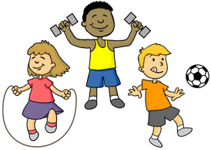

**Geography:**

Where does our food come from around the world?

Map skills

**D&T:**

Design, make and evaluate a mini-pizza

**Art:**

Observational drawing of fruit

**Computing:**

Use beebots and write algorithms

Debug algorithms

Purple Mash

**P.E**

Dance

**History:**

Find out about Edith Cavell and nursing in the past.

Compare nursing then and now.

**Extended Writing:**

Explanation about who Edith Cavell is.

**Science:**

How can we stay healthy?

Healthy eating

Exercise

**Real-life Maths:**

1. Using pedometers to count steps

2. Create a graph about our favourite foods.

**Keeping Safe and Healthy:**

Being confident and going for goals

**Big Writing Genres:** (as above)

**RE**

Judaism

What does it mean to be a Jew?

**Spanish:**

Dinocrocs

**Assembly Themes & Special Days:**

(see assembly timetable)

Class: Snowy Year Group: 1/2 Term: Spring 2 2018 Cycle: B