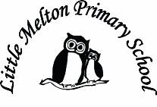

**Mathematics:**

*(Following White Rose Maths Hub)*

1. Measurement: Length and height

2. Place value – tens and ones

3. Place value – tens and ones, compare and order numbers

4. Counting – in 2s and 5s

5. Measurement – weight and volume

6. Assessment

Topic Title:

FIGHTING FIT!

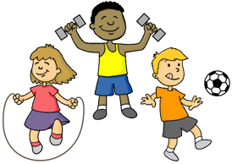

**Geography:**

Where does our food come from around the world?

Map skills

**D&T:**

Design, make and evaluate a mini-pizza

**Art:**

Observational drawing of fruit

**Computing:**

Use beebots and write algorithms

Debug algorithms

Purple Mash

**P.E**

Dance

**History:**

Find out about Edith Cavell and nursing in the past.

Compare nursing then and now.

**Extended Writing:**

Explanation about who Edith Cavell is.

**Science:**

How can we stay healthy?

Healthy eating

Exercise

**Real-life Maths:**

1. Using pedometers to count steps

2. Create a graph about our favourite foods.

**Keeping Safe and Healthy:**

Being confident and going for goals

**Big Writing Genres:** (as above)

**English:**

***Non-fiction - Instructions***

Instructions

Recipes

(Grammar – commands, CFFS, layout of instructions)

***Fiction – character-driven stories***

‘Bears don’t eat egg sandwiches!’ by Julie Fulton

(Punctuation to finish sentences -? and !)

***Poetry on a theme***

Use adjectives to write poems about food

**Spelling**: First 100 high frequency words

**RE**

Judaism

What does it mean to be a Jew?

**Spanish:**

Dinocrocs

**Assembly Themes & Special Days:**

(see assembly timetable)

Class: Snowy Year Group: 1/2 Term: Spring 2 2018 Cycle: B