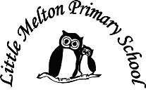
Extended Writing:
3rd person narrative about a food fight!
Keeping Safe and Healthy:
Friends

Assembly Themes & Special Days:
(see assembly timetable)

Whole School Focus Week/Day:

P.E.
Gymnastics
R.E:
Judaism

The Easter Story (Christianity)
English:

Non-fiction
“The World Came to my Place Today”

Poetry
“Tasty Poems”
To inspire poetry about chocolate at Easter.

Fiction – 3rd person Narrative
“Lady Pancake and Sir French Toast” by Josh Funk
(Grammar – adverbs, verbs, adjectives, sentence structure)

Spelling: Spellzoo spelling scheme will be followed throughout the half term, and HFW words will be sent home with a Spelling Quiz each week.
Big Writing Genres: (as above)
Descriptions of food, instructional recipe writing etc.

Class: Snowy Year Group: 1/2 Term: Spring 2 2016 Cycle: B
Music:
Music to accompany “Lady Pancake and Sir French Toast”

Mathematics:

(Following Hamilton Scheme)
1. Multiplication
2. Division
3. Measuring
4. Measuring and fractions
5. Assessment

Computing:
Morpho app on ipad
Paint program

Real-life Maths:
1. Measuring – capacity and weight
2. Statistics – favourite food

Topic Title:

Where does our food come from? 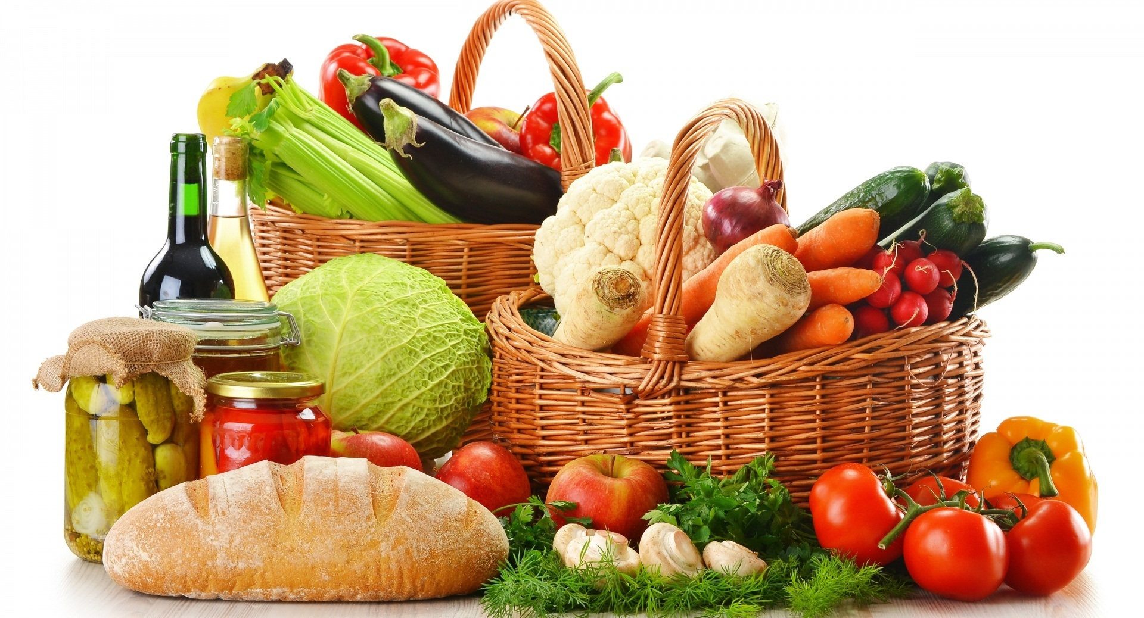

Geography:
Finding out where our food comes from.
Countries and continents
Science & D.T
Changing materials
(bread making)

Art:
Observational drawing

