

**Mathematics:**

*(Following Hamilton Scheme)*

1. Position, direction and movement.

2. Data collection

3. Addition and subtraction

4. Multiplication and Division

5. Money

6. Measurement

7. Assessment

**English:**

***Poetry***

Various rainforest poems to inspire writing own Kennings poem.

(Grammar – verbs, nouns)

***Fiction – 3rd person narrative***

“Wolf Won’t Bite” by Emily Gravett

(Grammar – words with contracted forms, exclamations)

***Non-fiction***

“We’re from Brazil” text

(Grammar – sentence types, present tense).

**Spelling**: Spellzoo spelling scheme will be followed throughout the half term, and HFW words will be sent home with a Spelling Quiz each week.

Children will also practise common spellings in line with the phonics focus.

**R.E:**

Weddings and how people celebrate them around the world.

**Keeping Safe and Healthy:**

Making and keeping friends

**Assembly Themes & Special Days:**

(see assembly timetable)

Class: Snowy Year Group: 1/2 Term: Summer 2 2016 Cycle: B

**Real-life Maths:**

1. Data collection – favourite rainforest animals

2. Addition and subtraction rainforest context

**Music:**

Sounds of a rainforest and music composition

Topic Title:

Brazil/The Olympics

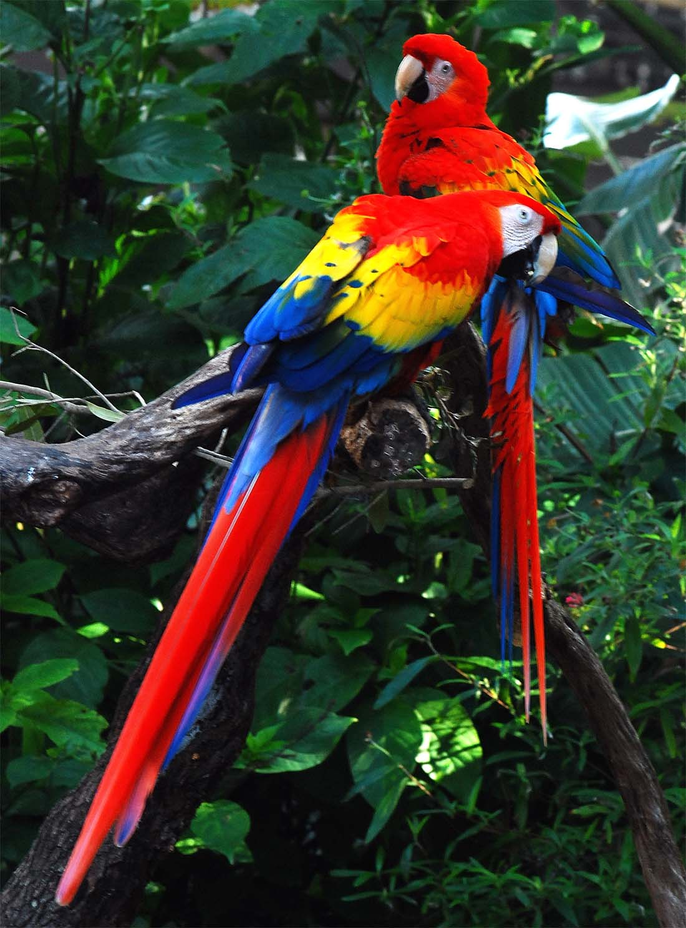

**D.T**

Design a rainforest game

**Geography:**

Compare Little Melton to Brazil.

Physical geography vocabulary.

Locating Brazil on maps and atlases.

**History**

The history of the Olympics.

**Computing:**

Beebots – giving instructions to move around the “rainforest”

Puppet Pals App

**P.E.**

Summer games

**Extended Writing:**

Non-fiction non chronological report about Brazil.

**Art:**

Camouflage art work

**Science:**

Animals in their habitats

Survival – camouflage

Plants in their environment

Food chains

**Big Writing Genres:** (as above)

Descriptive writing, imaginary story writing, letter writing.

**Whole School Focus Week/Day:**

Activities Week