

**History:**

The Great Fire of London 1666

Timeline of how it happened

Samuel Pepys’ diary

**Music:**

BBC School Radio –

Great Fire of London

Explore instruments and learn songs.

**Science:**

Suitability of materials for different purposes

Explore how shapes of solid objects can be changed by squashing, bending, twisting and stretching

**Art/DT**

Mixing hot colours

London’s burning silhouette

Plan, make and evaluate bread

**Computing:**

Algorithms (instructions) and debugging

Email (Purple Mash)

**Geography:**

Location of London and the capital cities in UK

**Extended Writing:**

Great Fire of London news article

**English:**

***Folk tale (North American Indian)***

How Rabbit Stole the Fire- Joanna Troughton

(Grammar: past tense, conjunctions, adjectives)

***Instruction writing***

Look at different sets of instructions.

Write instructions to make bread.

(Grammar: commands, verbs)

***Poetry***

On the theme of fire.

(Grammar: adjectives)

**Spelling**: High Frequency words

Months of the year

**Keeping Safe and Healthy:**

Being safe all around us

Sex and Relationship Education

**Mathematics:**

1. Addition

2. Subtraction

3. Capacity

4. Weight

5. 2D and 3D shape

6.Number sequencing/Assessment

7. Counting

**Spanish:**

Dinocrocs

**R.E:**

Judaism – What can Jewish people learn about God from the stories of Exodus?

Topic Title:

Fire fire!

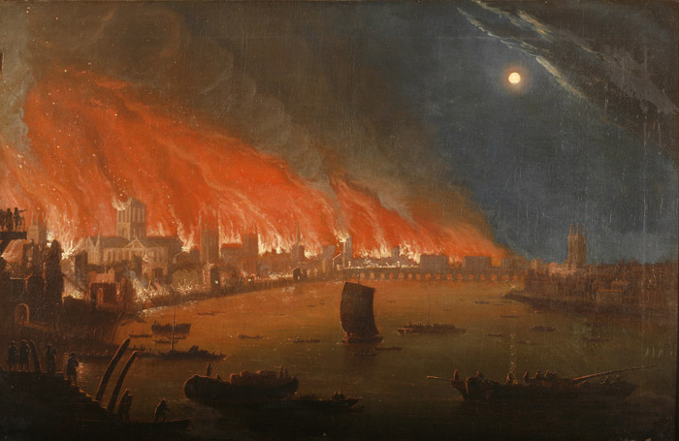

**Real-life Maths:**

1. Capacity of water to make bread

2. Weight of ingredients to make bread

3.Telling the time for bread to bake

**P.E:**

Outdoor multiskills

**Big Writing Genres:** (as above)

**Assembly Themes & Special Days:**

(see assembly timetable)

Class: Snowy Year Group: 1/2 Term: Summer 2 Cycle: A