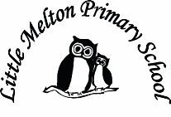

**History:**

The Great Fire of London 1666

Timeline of how it happened

Samuel Pepys’ diary

**Music:**

BBC School Radio –

Great Fire of London

Explore instruments and learn songs.

**Science:**

Suitability of materials for different purposes

Explore how shapes of solid objects can be changed by squashing, bending, twisting and stretching

**Art/DT**

Mixing hot colours

London’s burning silhouette

Plan, make and evaluate bread

**Computing:**

Algorithms (instructions) and debugging

Email (Purple Mash)

**Geography:**

Location of London and the capital cities in UK

**Extended Writing:**

Great Fire of London news article

**English:**

**Fiction:**

Stories from the same author- Anthony Browne (2 weeks)

Focus: Using speech marks

**Non-Fiction:**

Writing an Information Text

The Fire Service (2 weeks)

Focus: Organisational features

**Poetry:**

Poems with a Pattern

Poems about Fire (2 weeks)

Focus: Descriptive language, use of alliteration

**Spelling & Handwriting:**

Remaining Year 2 spelling rules

(see NC appendix)

**Keeping Safe and Healthy:**

Being safe all around us

Sex and Relationship Education

**Mathematics:**

1. Money

2. Shape

3. Length

4. Mass

5. Capacity

6. Time

7. Assess and Review

**Spanish:**

Dinocrocs

**R.E:**

Judaism – What can Jewish people learn about God from the stories of Exodus?

Topic Title:

Fire fire!

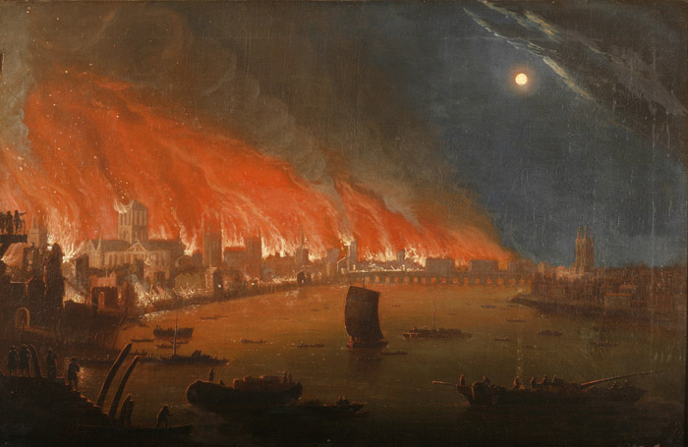

**Real-life Maths:**

1. Capacity of water to make bread

2. Weight of ingredients to make bread

3.Telling the time for bread to bake

**P.E:**

Outdoor multiskills

**Big Writing Genres:** (as above)

**Assembly Themes & Special Days:**

(see assembly timetable)

Class: Snowy Year Group: 2 Term: Summer 2 Cycle: A