Spring Term 2014
This term our theme is ‘Now and Then’ with a focus on the Victorians.
Literacy: Fiction genres, revision for KS2 SATs.
Maths: National Numeracy Strategy
‘Bread and butter’ learning (these are the things I need to be doing regularly).
- Reading e.g. my reading book / visiting Bug Club etc.
- Practice my spellings.
- Practice times tables.
- Complete weekly grammar homework.
- Complete weekly Maths homework.
- Talk Homework.

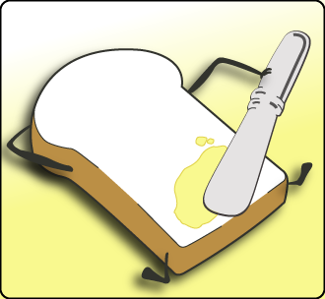

Victorian Cooking
Find a Victorian recipe of your choice. Follow it to make the food item. Take a photo and record the Maths you used when making it.

Victorian Science
Magnification
- Find pictures of plants, animals or objects which have been highly magnified. Remember to label details.
- Try to take a photo with unusual perspective. See example below.
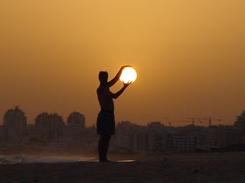
Alexander Bell
- Create a picture timeline of the history of the telephone.
- Make your own string phone. What is the largest piece of string you can get to work?

WALT
Working and Learning Together
Choose five of the following to complete over the next term. Fill in a record sheet and present your task in your special WALT book. This could be a photo of your activity, a drawing or a written task.
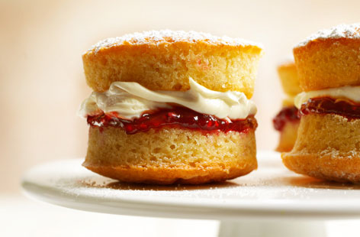

Victorian Authors
Lewis Carroll (Alice in Wonderland)
- Design a food plate for the Mad Hatters tea party. Draw and picture and write a description.
Charles Dickens (Oliver)
- Make a selection of porridges with different flavours (e.g. salt, sugar etc..) test on your family and make a graph of the results.
Robert Louis Stevenson (Treasure Island)
- Design your own treasure map which includes coordinates and clues to finding the treasure.
L. Frank Baum (Wizard of Oz)
- Design a character that has a missing characteristic (e.g. Lion without courage). Explain what could happen to show them they do have that characteristic really.

Victorian Chocolate - Cadburys
Cadburys Chocolate was founded during the Victoria era, so try these chocolate based activities!
- Ask your friends and family to try a
range of different chocolate bars.
Create a chart of their favourite bars.
- Design your own chocolate bar and
wrapper. Create a persuasive advert
for your bar.

