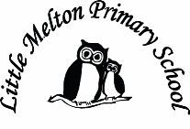

**English:**

***Fiction – adventure/journey story***

Oliver Jeffers- ‘Up and Down’

‘Lost & Found’

***Non-fiction – Information Texts***

Harry & The Bucketful of Dinosaurs

(Grammar – sentence punctuation)- apostrophes

***Descriptive poetry***

Favourite poems about the sea and sea creatures

**Spelling**:

Homophones

-al

/s/ spelt c

/u/ spelt o eg brother

-

**Music:**

Sun, Sea and Song (BBC)

Learning and performing songs

**Real-life Maths:**

1. Floating and sinking – measuring liquid

2. Position and direction – connected with geography map skills

**Computing:**

Coding on Espresso

Purple Mash

**Art:**

Observational drawing of sea creatures

Marbling

Using various media to create underwater art

**Extended Writing:**

Write a persuasive piece about saving the ocean from pollution.

**Mathematics:**

*(Following White Rose Maths Hub)*

Multiplication and division (multiples of 2,5 and 10) across first three weeks with the focus:

1. Position and Direction
2. Time
3. Time
4. Addition incl word problems
5. Subtraction incl word problems

Key Stage 1 SATS

1. Data-handling

**Keeping Safe and Healthy:**

First Aid and staying safe by water.

**Spanish:**

Dinocrocs

**P.E**

Maypole Dancing

Multiskills

Swimming (Y2)

**Big Writing Genres:** (as above)

**History:**

The true story of the Titanic

**Science:**

Investigative science – floating and sinking

Sea creature identification and classification

Habitats under the sea

Topic Title:

BLUE PLANET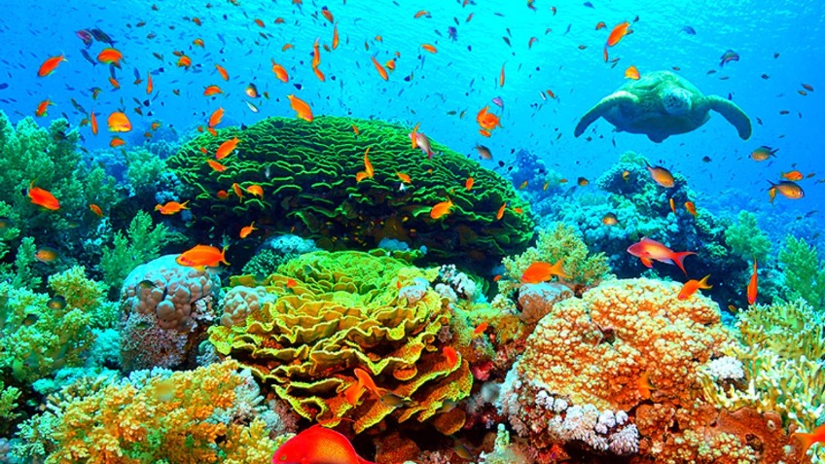

**Geography:**

Physical vocabulary to describe land and sea

Naming the seas and oceans

**Assembly Themes & Special Days:**

(see assembly timetable)

Class: Snowy Year Group: 1/2 Term: Summer 1 2018 Cycle: B