

**Computing:**

Debugging algorithms

Purple Mash software

Purpel Mash

Topic Title:

Once Upon A Time

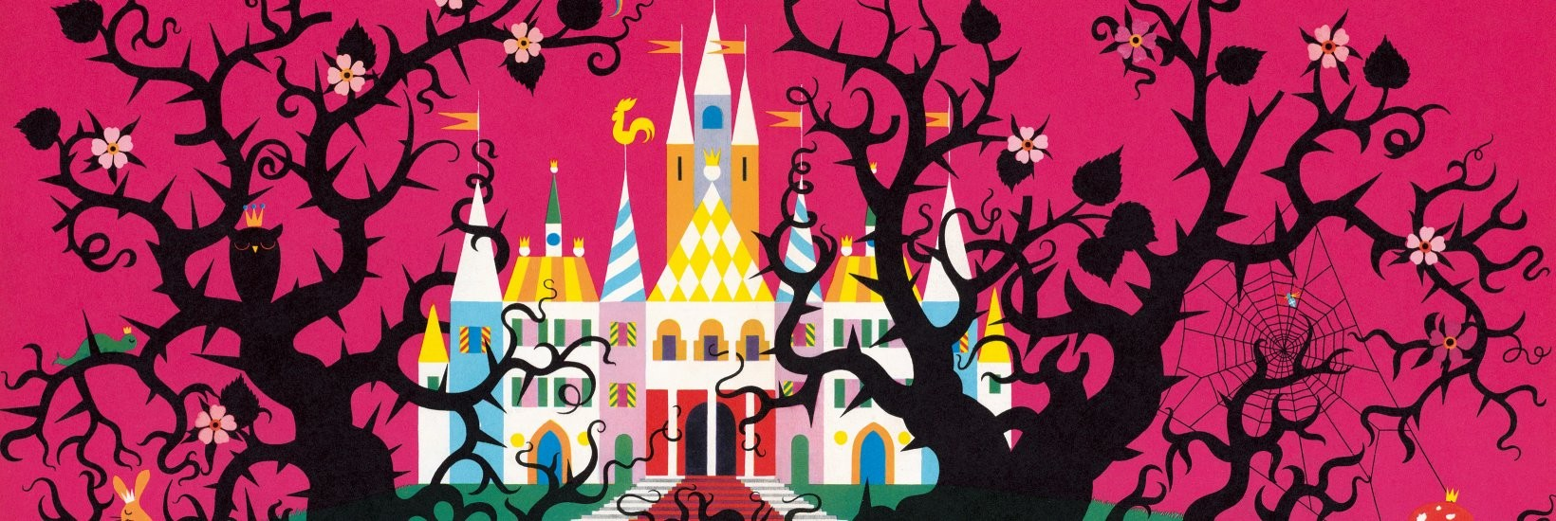

**Music:**

Christmas Play singing

and Carols.

**Art & D&T:**

Design and make a fairytale character puppet

Christmas cards

**Extended Writing:**

Story – write own story based on ‘Whatever Next!’ with own teddy.

**R.E:**

The Nativity story

Christianity – beliefs and worship

**Mathematics:**

*(Following White Rose Maths Hub)*

1. Number bonds to 10

2. Addition

3. Subtraction – how many are left

4. Subtraction – finding the difference

5. Addition and subtraction

6. 2D and 3D shapes

7. Assessment and review

**Real-life Maths:**

1. Shapes to make rockets

2. Christmas presents addition and subtraction

**Spanish:**

Dinocrocs

**Whole School Focus Week/Day:**

Christmas Play

**History:**

Kings and Queens

Queen Victoria and Queen Elizabeth II.

**Assembly Themes & Special Days:**

(see assembly timetable)

**Keeping Safe and Healthy:**

Being safe all around us

RIo

**Big Writing Genres:** (as above)

**P.E.**

Invasion games/Multiskills

**English:**

***Non-fiction*** – features of non-fiction texts e.g. photos, labels, diagrams etc.

***Fiction – adventure story***

Whatever Next! By Jill Murphy

(Grammar – use of ‘and’ conjunction, introduce ? and !)

***Fiction - fairytale***

Little Red Riding Hood

(Grammar – adjectives)

***Poetry*** – using our 5 senses on the theme of Christmas

(Adjectives)

**Spelling**: First 100 high frequency words

Class: Snowy Year Group: 1/2 Term: Autumn 2 2018 Cycle: A

**Science:**

Woodland habitats

Food chains