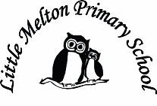

**Computing:**

Debugging algorithms

Purple Mash software

Purpel Mash

Topic Title:

Once Upon A Time

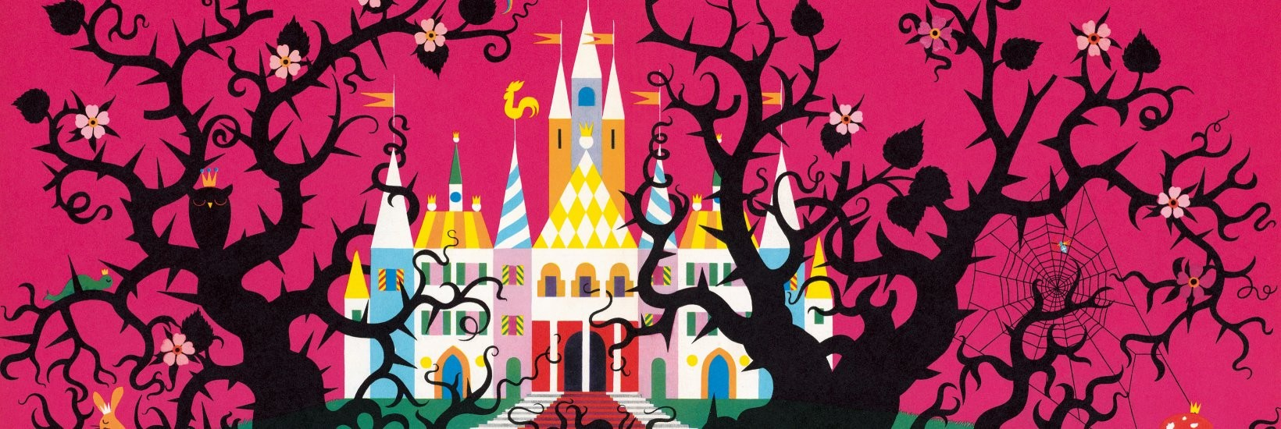

**Music:**

Christmas Play singing

and Carols.

**Art & D&T:**

Design and make a fairytale character puppet

Christmas cards

**Extended Writing:**

Story – write own story based on ‘Whatever Next!’ with own teddy.

**R.E:**

The Nativity story

Christianity – beliefs and worship

**Mathematics:**

*(Following White Rose Maths Hub)*

1. Add 2dig + 2 dig
2. Subtract 2dig-2dig
3. Bonds to 100
4. Add 3 numbers
5. Money-counting
6. Money- calculations
7. Assess and Review week

**Real-life Maths:**

1. Shapes to make rockets

2. Christmas presents addition and subtraction

**Spanish:**

Dinocrocs

**Whole School Focus Week/Day:**

Christmas Play

**History:**

Kings and Queens

Queen Victoria and Queen Elizabeth II.

**Assembly Themes & Special Days:**

(see assembly timetable)

**Big Writing Genres:** (as above)

**P.E.**

Invasion games/Multiskills

**English:**

***Fiction – Traditional Tales***

Variety chosen- discuss common features and different versions

Write own ending to a familiar story

***Non-fiction*** – Kings and Queens of England

Using non-fiction conventions- headings, sub-headings, bullet points and labelled diagrams

***Poetry*** – using our 5 senses on the theme of Christmas

(Adjectives)

**Christmas Week-** Babushka story

**Spelling**: Individual word packs

**Grammar**: Y2 list- conjunctions focus

Class: Snowy Year Group: 2 Term: Autumn 2 2018 Cycle: A

**Science:**

Woodland habitats

Food chains

**Keeping Safe and Healthy:**

Being safe all around us

Healthy Eating