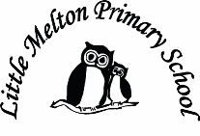

**Extended Writing:**

What happened to Ernest Shackleton?

**Geography:**

Where are the polar regions?

The continents and oceans of the world.

Map skills

Topic Title:

**FROZEN!**

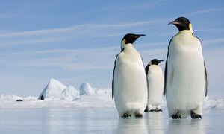

**Computing:**

Use beebots and write algorithms

Debug algorithms

Purple Mash

**Outdoor learning:**

Observe nature in the winter months – changes over time

Make bird food cakes

**Spanish:**

Dinocrocs

**Music:**

Rhythm and tempo (‘March of the Penguins’ as inspiration

**History:**

Ernest Shackleton the explorer.

**Art/D&T:**

Penguin collage, drawing

Hot/cool colours using different media

**Mathematics:**

*(Following White Rose Maths Hub)*

1. Growth mindset in maths

2. Place value – tens and ones, compare and order numbers

4. Counting – in 2s and 5s

5. Measuring – length and height

6. Measurement – weight and volume

7. Time /Assessment

**Science:**

Freezing and melting

Investigating and planning experiments

Animals in the polar regions

Life cycle of a penguin

**Real-life Maths:**

1. 2D and 3D shape hunts
2. Measuring and comparing heights of penguins

**P.E**

Gymnastics

**Big Writing Genres:** (as above)

**English:**

***Recount – Non-fiction***

The Emperor’s Egg (Martin Jenkins)

(Grammar – CFFS)

***Adventure story***

Lost and Found (Oliver Jeffers)

(Grammar – use of ‘and’ in sentences)

***Poetry*** – using our 5 senses

**Spelling**: First 100 high frequency words

Class: Snowy Year Group: 1/2 Term: Spring 1 2019 Cycle: A

**Keeping Safe and Healthy:**

Being safe with money

**Assembly Themes & Special Days:**

(see assembly timetable)