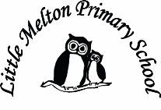

**Mathematics:**

*(Following White Rose Maths Hub)*

1. Growth mindset in maths

2 Division 1

3. Division 2

4. Statistics 1

5. Statistics 2

6. Assess and Review week

**Extended Writing:**

What happened to Ernest Shackleton?

**Geography:**

Where are the polar regions?

The continents and oceans of the world.

Map skills

Topic Title:

**FROZEN!**

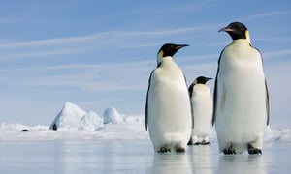

**Computing:**

e-safety

Email- Purple Mash

**Outdoor learning:**

Observe nature in the winter months – changes over time

Make bird food cakes

**Spanish:**

Dinocrocs

**Music:**

Rhythm and tempo (‘March of the Penguins’ as inspiration

**History:**

Ernest Shackleton the explorer.

**Art/D&T:**

Penguin collage, drawing

Hot/cool colours using different media

**Science:**

Freezing and melting

Investigating and planning experiments

Animals in the polar regions

Life cycle of a penguin

**Real-life Maths:**

1. 2D and 3D shape hunts
2. Measuring and comparing heights of penguins

**P.E**

Gymnastics

**Big Writing Genres:** (as above)

**English:**

***Instructions – Non-fiction***

Building a Snowman

Surviving in the cold

(Grammar – Imperative verbs & adverbs)

***Adventure story- Fiction***

Sophie Scott Goes South (Alison Lester)

(Grammar –adverbs)

***Poetry*** – using our 5 senses-descriptive writing

**Spelling**: Individual spelling packs

Class: Snowy Year Group: 1/2 Term: Spring 1 2019 Cycle: A

**Keeping Safe and Healthy:**

Being safe with money

**Assembly Themes & Special Days:**

(see assembly timetable)