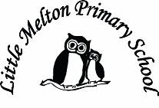

**Mathematics:**

*(Following White Rose Maths Hub)*

1. Subtraction – not crossing 10
2. Subtraction – crossing 10
3. Addition and subtraction – comparing number sentences
4. Count in 2s, 5s and 10s
5. Measuring and comparing capacity
6. Assessment

**Spanish:**

Dinocrocs

**Science:**

Plant parts

How do plants grow?

Investigate how best plants grow

seed > plant

Looking after our planet

**Extended Writing:**

Keep a bean diary (linked to Science)

**Keeping safe and healthy:**

Making and keeping friends

Anti-bullying

**Outdoor learning:**

Scavenger hunt

Sorting – alive/dead/never been alive

Sketching of plants

Noticing the new season – changes over time

**R.E**

Christianity – What can Christians learn about God from the Easter stories?

**P.E**

Dance

**Computing:**

Purple Mash

**Assembly Themes & Special Days:**

(see assembly timetable)

**Music:**

We’re Going on a Bear Hunt – following a score, using instruments and voices creatively.

**Art/D&T:**

Paper weaving

Weaving with other materials

**Geography:**

The four countries of the UK.

Map skills

Capital cities of UK.

**Real-life Maths:**

1. Measuring the height of plants
2. Measuring capacity of water to give to plants

Topic Title:

**Our Wonderful World**

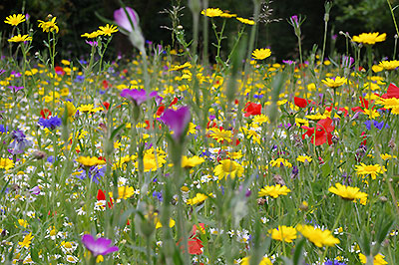

**Big Writing Genres:** (as above)

**English:**

***Traditional Tale***

Jack and the Beanstalk

(Grammar – CFFS, time conjunctions)

***Explanation Text***

How do plants grow?

(Grammar – time conjunctions)

***Poetry***

Acrostic poems about flowers, trees and plants

**Spelling**: Individualised spellings from High Frequency Words.

Class: Snowy Year Group: 1/2 Term: Spring 2 2019 Cycle: A