‘Keeping Safe and Healthy in the Modern World’- (September 2019)

Cycle A

 | Year 1/2 | Year 3/4 | Year 5/6
Autumn Term  1st half | E-safety | E-safety | E-safety
Autumn Term  2nd half | Keeping Safe & Managing Risk | Keeping Safe & Managing Risk | Keeping Safe & Managing Risk
Spring Term  1st half | Mental Health & Wellbeing | Mental Health & Wellbeing | Mental Health & Wellbeing
Spring Term  2nd half | Drugs and Tobacco Education | Drugs and Tobacco Education | Drugs and Tobacco Education
Summer Term  1st half | Physical Health & Wellbeing | Physical Health & Wellbeing | Physical Health & Wellbeing
Summer Term  2nd half | RSE | RSE | RSE

Cycle B

 | Year 1/2 | Year 3/4 | Year 5/6
Autumn Term  1st half | E-safety | E-safety | E-safety
Autumn Term  2nd half | Keeping Safe & Managing Risk | Keeping Safe & Managing Risk | Keeping Safe & Managing Risk
Spring Term  1st half | Mental Health & Wellbeing | Mental Health & Wellbeing | Mental Health & Wellbeing
Spring Term  2nd half | Careers, financial capability & economic wellbeing | Careers, financial capability & economic wellbeing | Careers, financial capability & economic wellbeing
Summer Term  1st half | Physical Health & Wellbeing | Physical Health & Wellbeing | Physical Health & Wellbeing
Summer Term  2nd half | RSE | RSE | RSE

Curriculum coverage based on:
(i) Islington ‘You, Me and PSHE’ programme 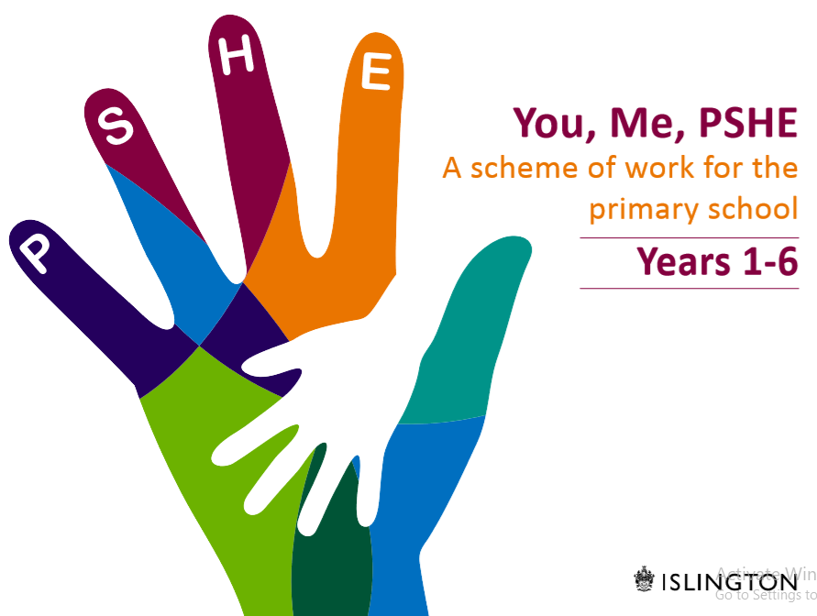
(ii) Norfolk Educator Solutions ‘RSE Sorted’ programme 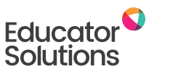

(iii) DfE online safety advice and recommended resources (2019)

