Knowledge Organiser: Space
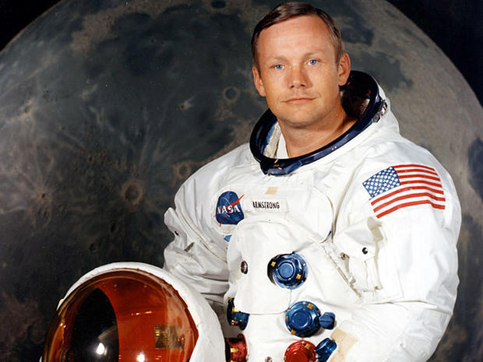  Neil Armstrong – the first man to walk on the moon on July 21st, 1969. | 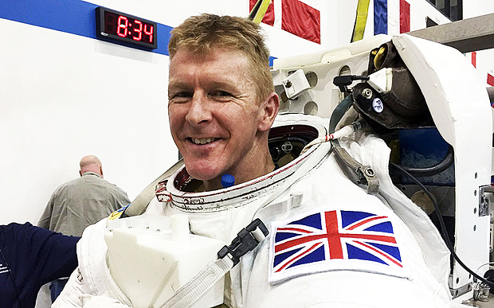  Tim Peake – the first British astronaut to walk in space (2016) | The International Space Station  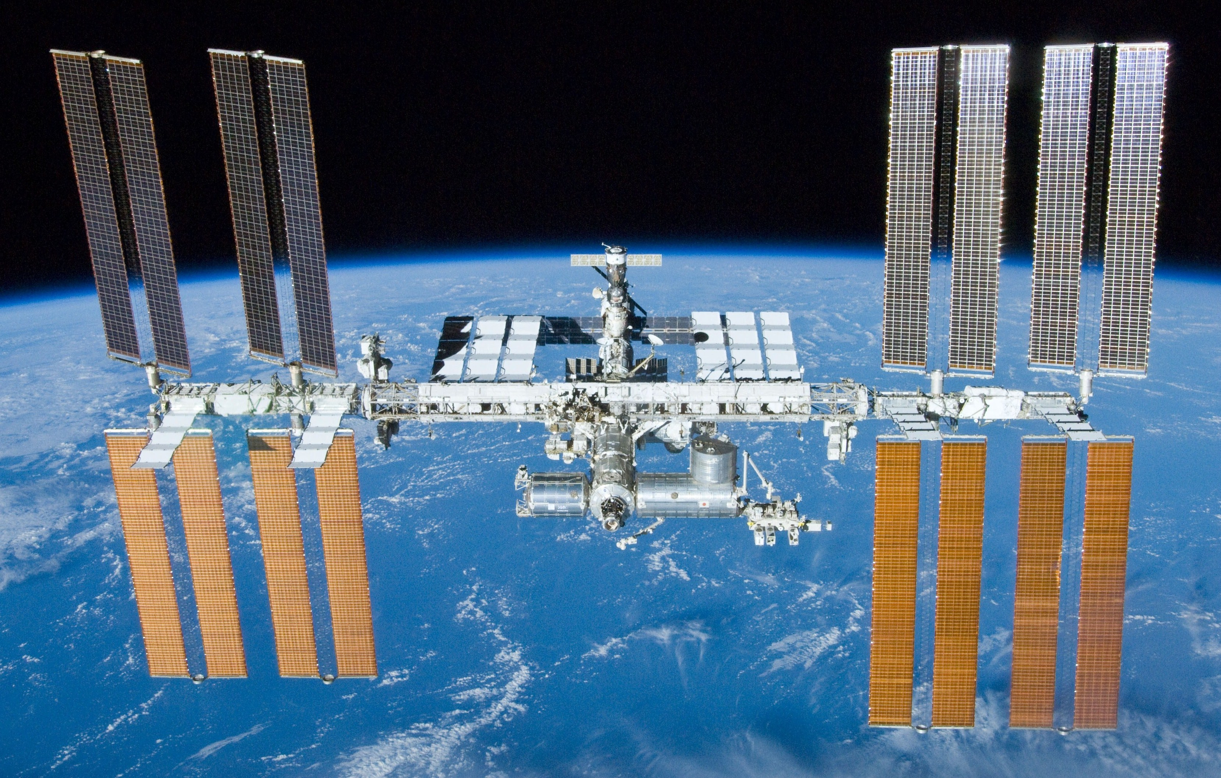
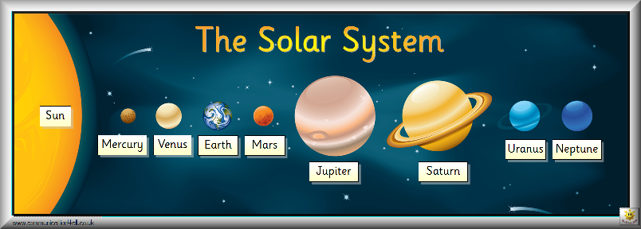  The Planets – Mercury, Venus, Earth, Mars, Jupiter, Saturn,  Uranus and Neptune (My Very Educated Mother Just Served  Us Noodles - mneumonic)  Open the door…  https://www.nasa.gov/kidsclub/index.html  https://www.esa.int/kids/en/learn |  | 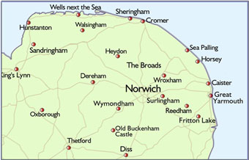  Norwich (our closest city)  Norfolk (our county)  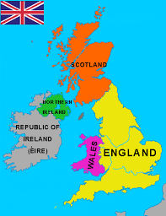  United Kingdom >  made up of  England  Scotland  Wales  Northern Ireland

