Knowledge Organiser: Weather and Nature
Vocabulary - Weather  hail - frozen rain that is in the shape of pellets  fog - cloud that touches the ground, it can be very thick  temperature - a number (usually in celsius) that tells us how hot or cold it is, measured with a thermometer  rainfall - the amount of rain or drizzle that falls, measured with a rain gauge  weather forecast - scientists predict what the weather will be like and display it on a map |  |  | Vocabulary - Nature  alive - a person, animal or plant is not dead and continues existing  dead - no longer alive  never alive - anything metal, plastic or stone has never been alive  food chain - the order of animals and plants that eat each other (called producers and consumers)  producer - a living thing that makes its own energy  consumer - a living thing that does not make its own energy  habitat - the natural home or environment of a plant or animal  forest - a large area covered mainly with trees and other plants  woodland - a smaller area covered with trees and other plants
Weather forecast:  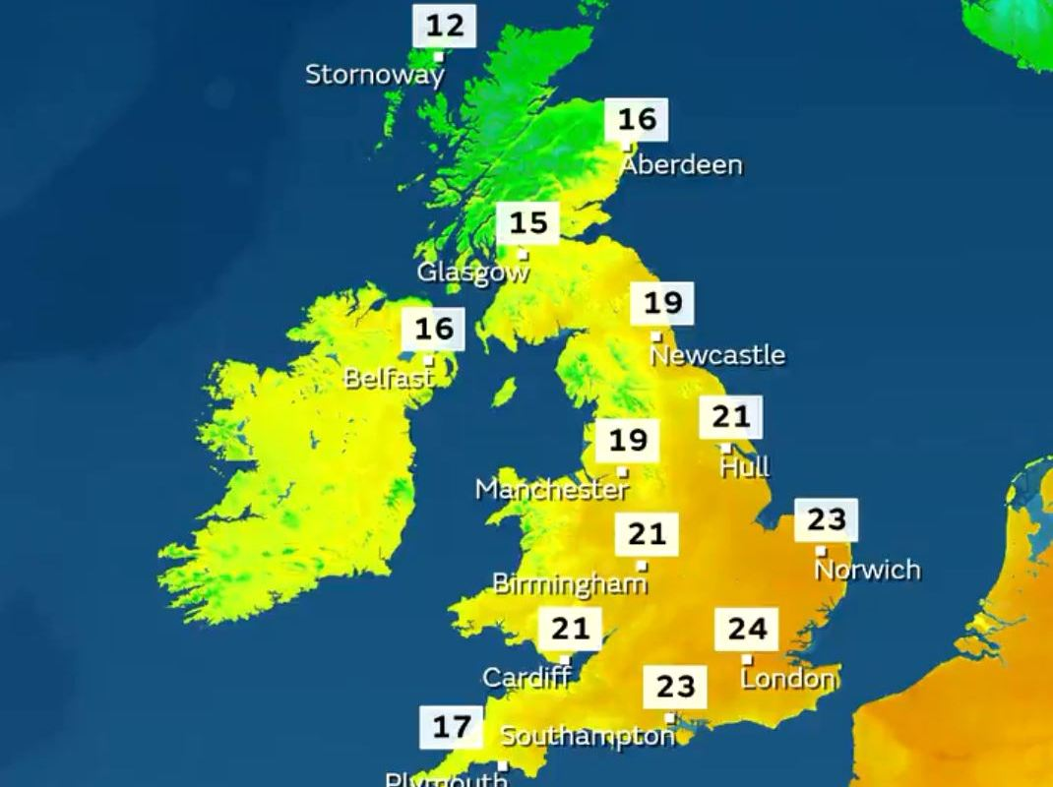 |  | Compass directions:  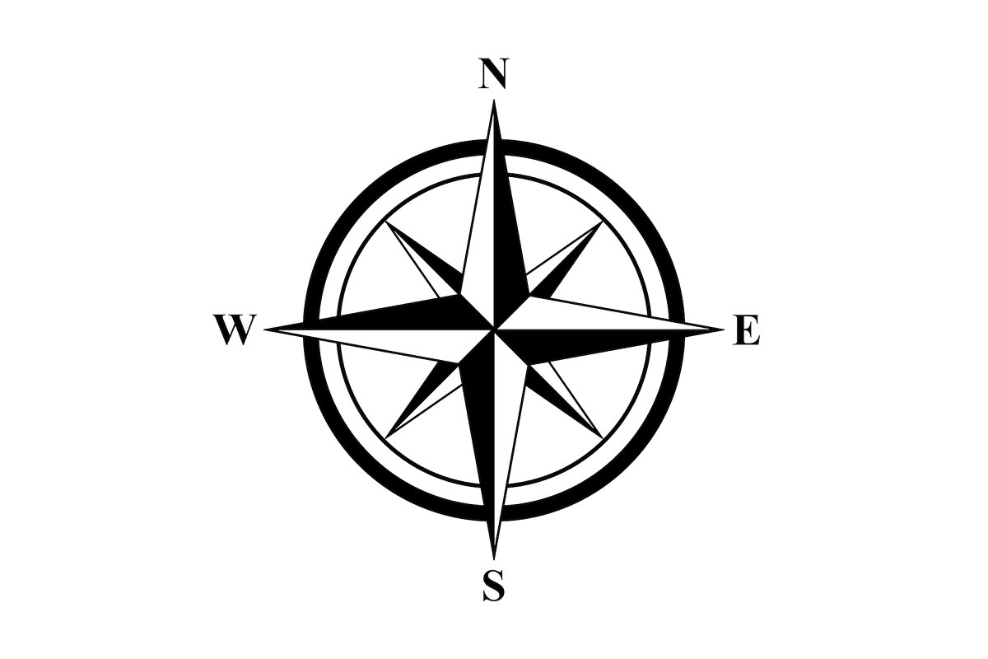  North East South West  (Never Eat Shredded Wheat) |  |  |  | The four seasons:  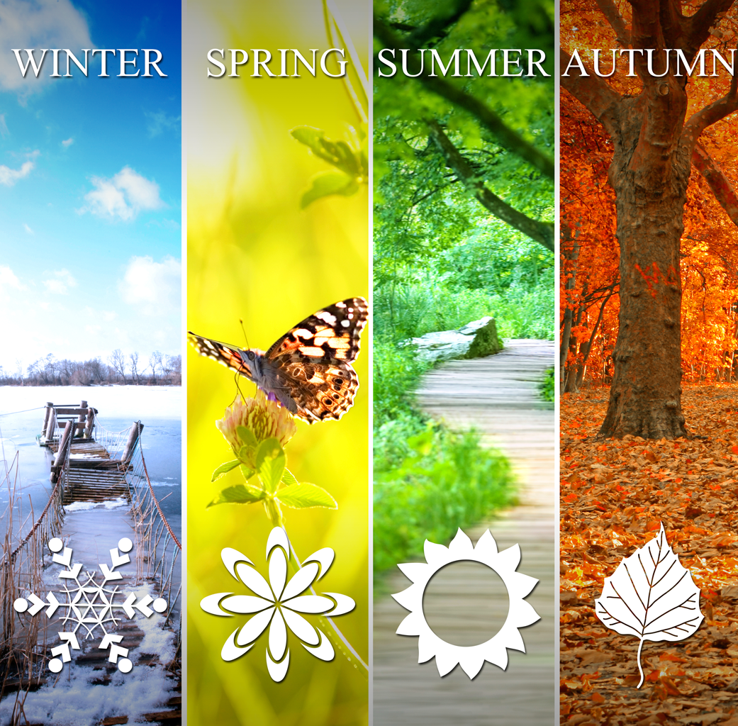
Open the door…
https://www.bbc.co.uk/bitesize/topics/z6882hv/articles/zs73r82
‘A First Book of Nature’ - Nicola Davies

