Eagle Owls Living Things and their Habitats – Knowledge Organiser
Key Vocabulary
Characteristics: features of a living creature which are used to identify them.  Classification: ordering living things into groups based on their similarities.  Evolution: The way that living things change over time.  Fossils: A fossil is the preserved remains or traces of a dead animal or plant.  Classification Key: Questions that can help decide which group a living thing belongs to.  Microorganisms: very small living creatures (magnification is needed to view)  Offspring: When living things reproduce, their young can be called offspring.  Species: Groups of plants and animals that are very similar to each other and can produce offspring.  Variation: The differences between species of plants and animals. |  | 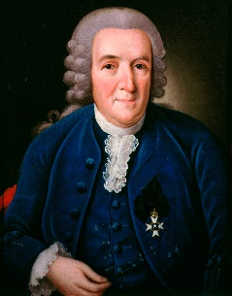  Important Scientists:  Carl Linnaeus: was a Swedish scientist  who created the classification of living  things system that we use today.  (See diagrams below.)
Unlock more knowledge by reading and / or visiting:
Website(s): https://www.bbc.co.uk/bitesize/topics/z6wwxnb
https://www.bbc.co.uk/bitesize/topics/zn22pv4/articles/z3nbcwx
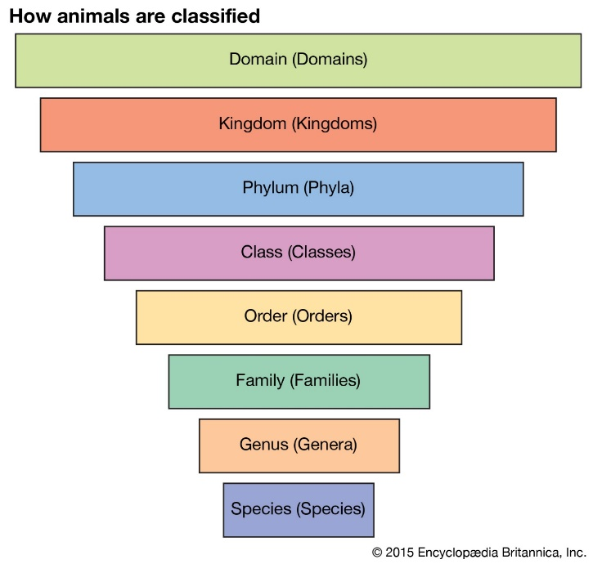  Key Scientific Vocabulary:  Observe, identify, classify, group, compare, contrast, research, labelled, conclusion, interpret. | 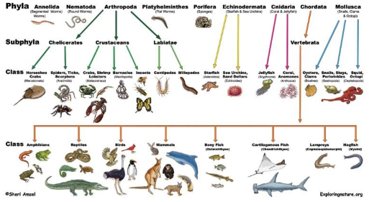  Animal Classification Key

