Talk Homework – Friday 27th March
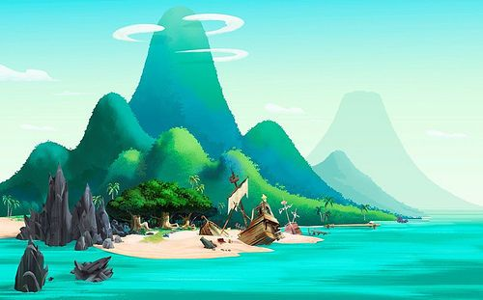

Imagine that you have been shipwrecked on a deserted island.
Talk about the following things:
- Where was your ship heading?
- Who was you with?
- How did the shipwreck happen?
- What happened when you went exploring?
- How did you get home?

