BIG WRITING – Monday 20th April
- Look at the pictures on page 2 of this document. What do you think this place is? What happens here?
- What can you see in the images? Imagine that you can walk around this world – what can you see, smell, hear, touch, feel…?
- Spend some time collecting words and phrases to describe the pictures.
- Remind yourself of the different descriptive techniques that you know – adjectives, powerful verbs, adverbs, similes, showing not telling, ISPACE …
- Use ‘Describing a forest’ resource on page 3 and 4, to look at creating effective and descriptive sentences.
- Today your task is to write a description of the world in the pictures.
- Allow yourself some planning time first before you start writing.

Monday 20th April
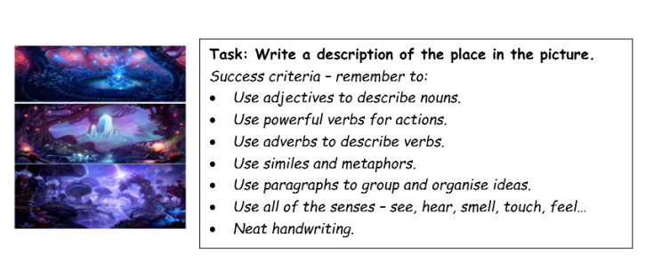

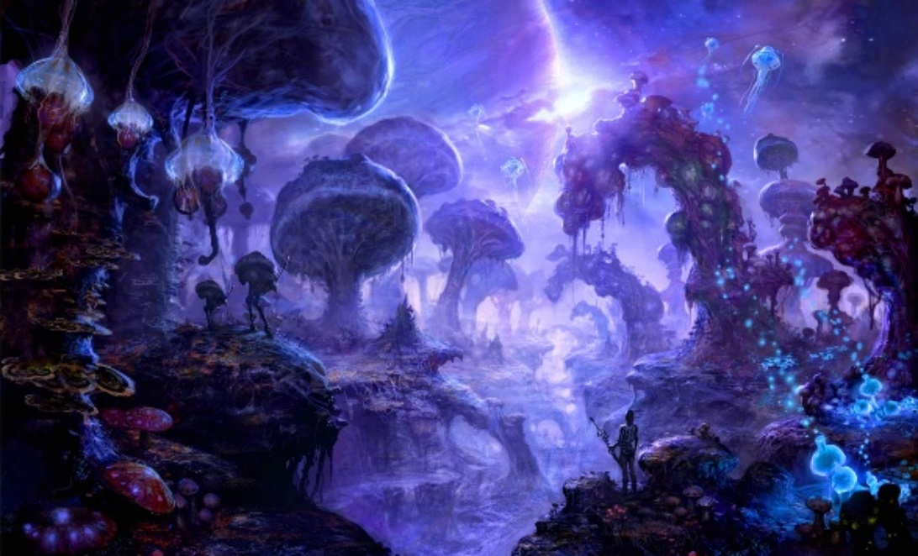

DESCRIBING A FOREST

LEVEL 1: BASIC SENTENCES
1. The forest was nut-brown. COLOUR
2. The twigs were crunching under my feet. SOUND
3. The trees were the towers of the forest. METAPHOR
4. I heard a wildcat slinking away. ANIMAL SOUNDS
5. The morning stars shone like silver petals. THE STARS
6. Nuts were scattered on the floor of the forest. FOREST EDIBLES
7. We took the leaf-carpeted path home. OTHER IMAGES
8. The beauty of the forest comforted our hearts. SENSATION
9. The smell of the forest was pulpy. SMELL
10. We picked some berries and they tasted orchard sweet. TASTE

LEVEL 2: A BASIC PARAGRAPH
The forest was tannin-brown. The grass was crispy under our feet. We looked up and the trees were skyscraper tall. Hares were scampering away from us up ahead. The morning stars were shining like silver snowflakes. Wood sorrel flecked the blanket of grass. We walked in and out of shady glades. The peace of the morning was soul soothing. The forest’s smell was fresh and organic. We picked some wild pears and they were meadow sweet.

LEVEL 3: CREATIVE PARAGRAPHS
The forest we entered was oak-brown and primitive. The grasses we stepped on were crackly beneath our feet because of the recent dry spell. We were in awe of the size and majesty of the trees. Their knotted arms rose ever upwards, as far as my head could lift. They were hoary fortresses and stood proudly. The orchestra of birdsong we could hear from them suddenly stopped. A pair of jays was screeching high up in the canopy of the trees. Jays are the scavengers of the bird world. Their cruel, corvid eyes are always on the lookout for a feathered meal. In the winter, they raid squirrel stores for their nuts, often damning them to starvation. They drifted across our vision in a flash of flesh-pink and warlock-black, trying to size us up. That was the last we saw of them, as they are a furtive bird, full of suspicion.
The morning stars peeped down at us like silver asters, glinting and shimmering. They looked happy in their solar-silver isolation. We could see wild basil growing freely on the clumpy, mossy mattress of the floor. The simpering wind carried a fragrance with it. It was spirit refreshing to smell the mulchy mix of the forest’s perfume. We ate a few windfall apples and they were mead sweet with a bitter twist. It was only after we got the stomach cramps that we regretted it.

LEVEL 4: ADVANCED PARAGRAPHS
We were walking through an umber-brown, ancient forest. It reeked of age. Its woody incense was from centuries of snapping branches crashing to the forest’s floor and rotting silently. The composting, organic smell rose up in waves like a miasma. Every sprawling tree we passed under reminded me of a watchful guardian, a silent sentinel of the groves. We decided to venture deeper into the tangled heart of this primeval forest. We hoped that it would reveal its dark secrets to us.
The further we went, the more mystical and spellbinding it became. Huge roots spread-eagled the ground, twisting like the great backs of sea dinosaurs. The foliage became thick and lush, forming an arch of fairytale-green above our heads. Arthritic boughs, gnarled with age, dripped their bounty of nuts onto the path. Briars, brambles and berry trees flanked the trail, making it impenetrable on either side. Shuffling noises came from deep in the interior, deadened by the cunningly woven web of leaves. A troupe of shambling badgers crossed the winding trail in front of us at one point. They were finishing up their early morning foraging and looked startled to see us.
We arrived at a wide glade, where the trees fell away, revealing the bespeckled sky. The last of the morning’s stars were glinting like silver pin pricks, luminous and bright. An ore gold moon hung quietly in the distance, casting a honeyed sheen over the trees. We sat down with our backs against a lightning blasted tree trunk and watched it fade away. As if on cue, an avian aria erupted from the knot of trees. The solitary songbird was soon joined by his beaked companions, creating a symphony of song. The heart haunting melody was an elixir for the soul. The sap sweet fragrance of the forest washed over us and we were seduced by its comforting goodness. We placed some stinging nettle leaves into the broth we were brewing and it added a tingling, chlorophyll flavour. When we were leaving, I risked a glance over my shoulder. The forest glade looked freeze frame perfect in the enhanced light of the full dawn.

