King Henry VIII
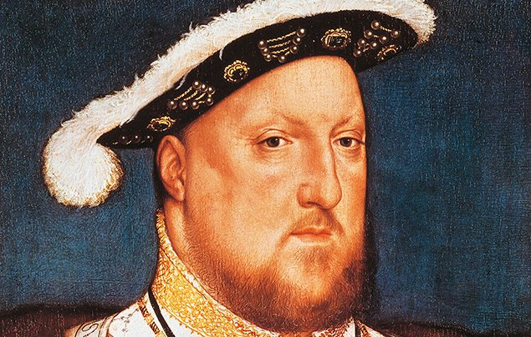

Who was Henry VIII?
Henry VIII was King of England and Ireland from 21 April 1509 until 28 January 1547, and is perhaps one of the most famous monarchs in English history.
Born on 28 June 1491 at Greenwich Palace in London, Henry was the second eldest son to Henry VII and Elizabeth of York.
The young prince was never expected to become king, but when his older brother, Arthur, Prince of Wales, died unexpectedly at the age of 15, Henry became heir to the throne.
Upon the death of his father, Henry was coronated on 24 June 1509 — he was just 17 years old. He immediately set about marrying his elder brother’s widow, Catherine of Aragon.

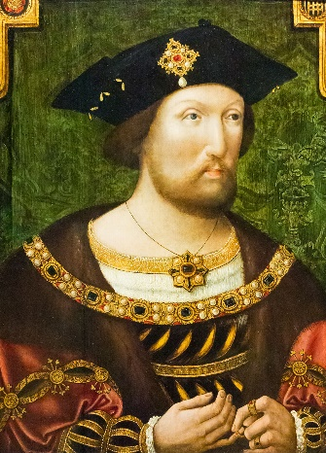
What was Henry VIII like?
The young King Henry was said to be handsome, clever and fun in contrast to his boring father. He was over six feet tall and loved jousting, hunting, composing music and throwing big, expensive parties!
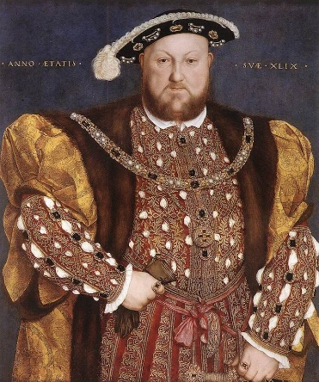
He loved spending money. The Tudor era was a time of great change, new ideas were emerging about science, art, design and culture, and great sailing expeditions uncovered new lands. Henry wanted to show off all his wealth and built many magnificent palaces — like Hampton Court Palace — and castles that would impress his subjects and rivals.
But, in his later years, all that indulgence took its toll on his physical health. The older King Henry was hugely overweight and struggled to walk. At the age of 50 he had a 54-inch (137cm) waist! He also suffered from a gruesome ulcer on his leg that caused him constant pain — which may have explained his bad temper!
Henry is known for being a ruthless King who ruled with an iron fist. Strong-willed and bullish, he handed out executions to anyone who stood in his way. In fact, during his 38-year reign, it is said he had more than 70,000 people executed — yikes!

