A quick guide to using Google Classroom

G Suite for Education
Your children already use Google Drive, Docs, Sheets, Slides, YouTube and more in their lessons and to produce work in Computing. The suite of productivity tools allows students and teachers to collaborate in real-time to create documents, presentations, surveys, spreadsheets and even websites. All tools are free, ad-free, reliable and secure. Parents are encouraged to sit down with their children to look at the school work stored within the Google Classroom.

Google Classroom - Website
Your child can access Google Classroom by logging in at http://classroom.google.com/ using their school account (_____@lmp.org.uk). Once work is completed, your child can ‘turn in’ their work to the teacher, or mark it as ‘submitted’.

Google Classroom - Mobile Phones and Tablets
If you wish, you can help your children to install the Google Classroom, Google Drive, Google Docs and Google Slides app on their device. This will allow them to access their assignments directly, as well as submit work, check deadlines and contact the teacher. Each app should be logged into with their school account.

**********************************************************

When pupil’s first log into Google Classroom they will see a page similar to the one below. To the left, they will see the class they are a part of and to the top right the initial of their first name. From here, they should click onto their class.
Once inside their Classroom, they will be on a tab titled ‘Stream’. This is the hub of the Classroom in which children will see assignments. They also have the ability to ask questions to the teacher or to their peers in order to gain clarity and support on their assignments; children may also want to share useful websites they have found or tips on completing the work.
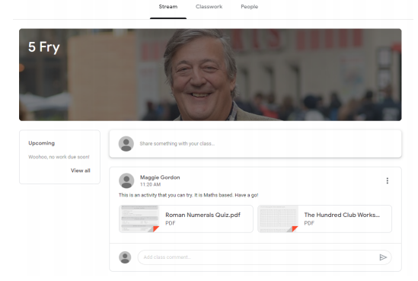
The second tab is titled ‘Classwork’. Although classwork does appear on the Stream - the classwork tab is the streamlined location to find the assignments directly from the teachers.

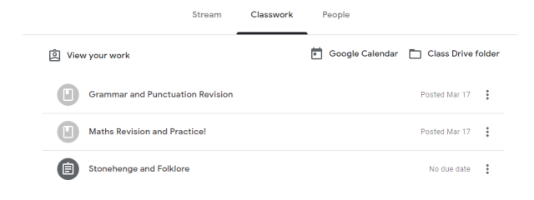

Below is an example of an assignment. The children are provided with key details on how to complete the assignment along with appropriate websites to help complete the tasks. Once work is complete, they can ‘Turn In’ their completed work. This can be seen to the right of the page. Teachers may comment on completed work to provide feedback to the children.

