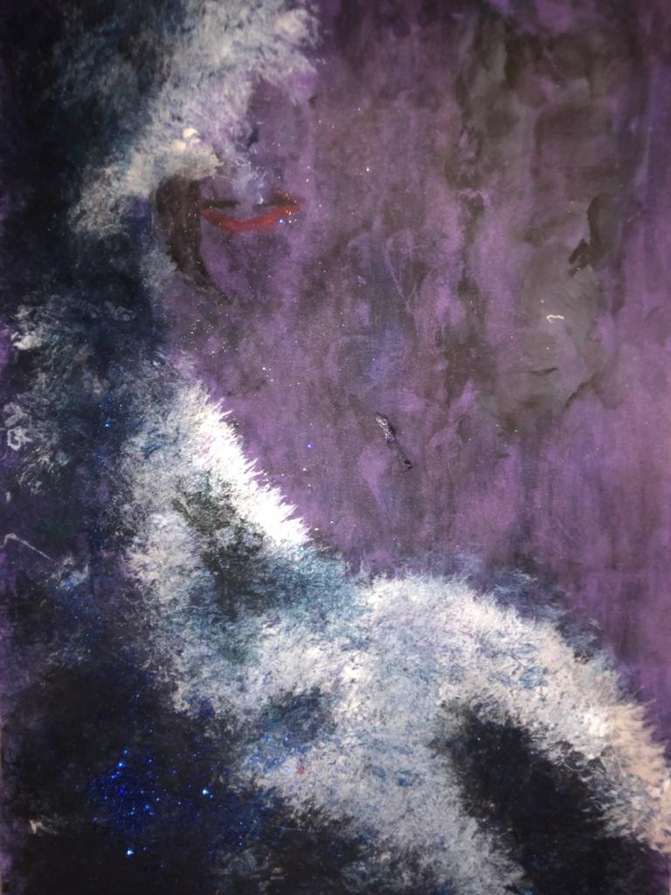
I used purple paper, and a wide bristled brush for the sea and the waves, then wet cotton wool dabbed in paint for the sky. I painted a ship, then dabbed lightly with cotton wool that had very watered-down dark paint on. I used black, blue, white, silver, green and purple paints. I wanted to make my boat stand out a little so gave it a red sail.

Mrs McIntyre May 2020

