Catch It - Lesson 2
https://www.literacyshed.com/catchit.html

Collective nouns are used to name a group of animals.

A group of meerkats is called a ‘mob’.

Here are some other examples:
• A school of fish
• A murder of crows
• A herd of elephants

Look at the animals below- can you find out the collective nouns for a group of each?

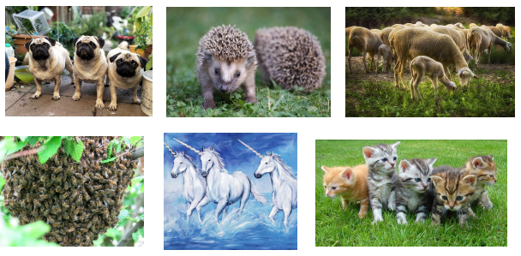
How many other collective nouns can you find out?
Draw a picture for each. Can you find at least 5?

