I would like you to have a look at these paintings. What do they have in common?

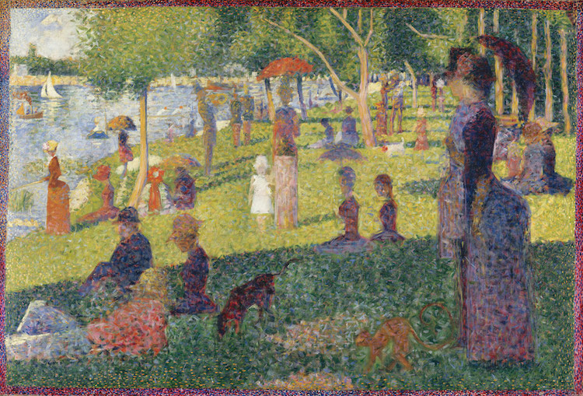
A Sunday Afternoon on the Island of La Grande Jatte (1884-1886) by Georges Seurat

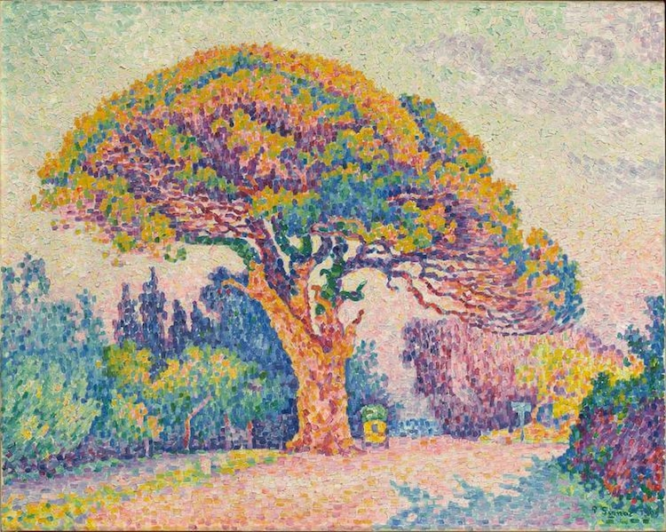
The Pine Tree at Saint Tropez (1909) by Paul Signac

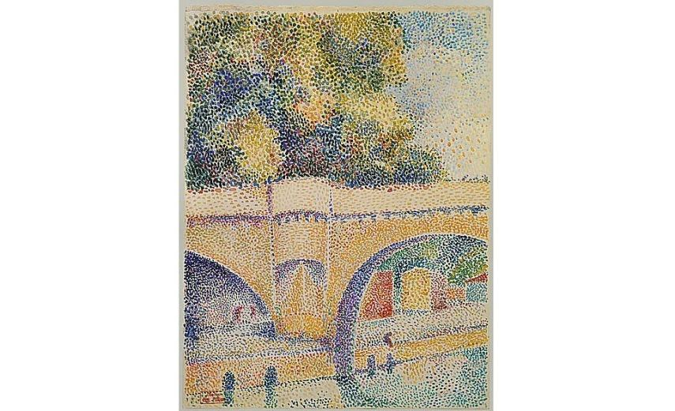
Hippolyte Petitjean - Pont neuf 1912–14
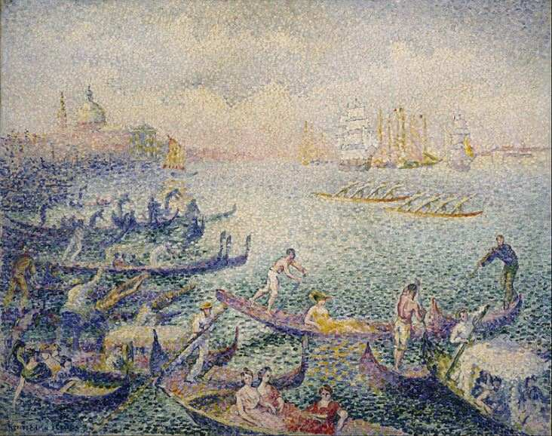

Henri Edmond Cross - Regatta in Venice, 1903-4

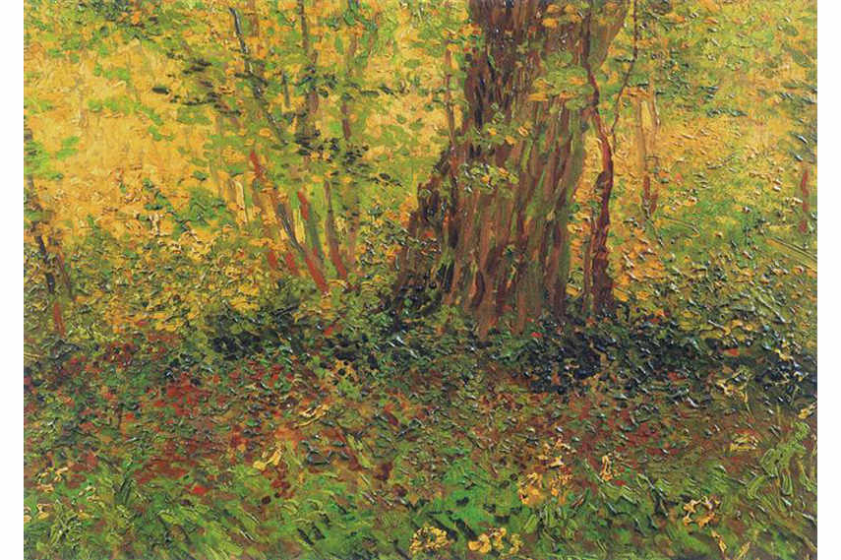

Vincent van Gogh - Undergrowth, 1887

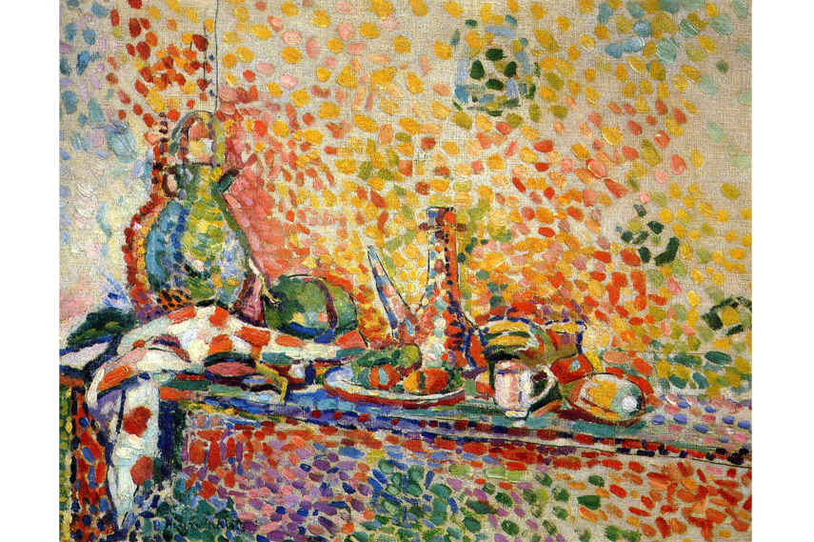
Henri Matisse

They are painted using Pointillism which was a technique used by artists in the 1800s. Pointillism is a specific way of applying the paint to the canvas.

Artists would create colours from lots of small dots placed close to each other that they would blur into an image to the eye. This is the same way computer screens work today. The pixels in the computer screen are just like the dots in a Pointillist painting.

I would like you to create your own pointillist pictures. You can use anything you like to make the dots, like paints, felt tips, stamps or your fingers. You could even do one on the computer.
I painted a rainbow using paints and cotton wool buds. (I’m sure you can all remember how much I liked rainbow colours).
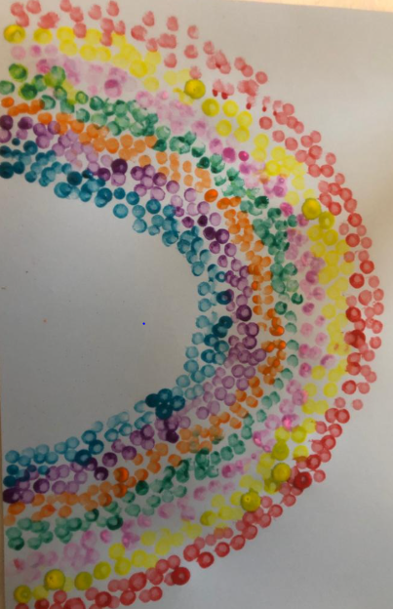
Mrs McIntyre-Rainbow- 2020

You can make your picture of anything, but it must be created using dots.

I look forward to seeing all your beautiful, pointillist masterpieces

