Hello Barn Owls
This week you have a celestial challenge.
There are 8 planets in our solar system including the Earth. Watch this video of the planets introducing themselves.
https://www.youtube.com/watch?v=PCxjuDePdCI
Today you are working for the Intergalactic Travel Agency. I need you to make a poster about Earth as a holiday destination for aliens. You will need to look up facts about the Earth that would make any distant holidaymakers want to visit our planet.
To get you started, have a look at this web page from Nasa for lots of information about our special planet. https://spaceplace.nasa.gov/all-about-earth/en/
Think about what would make the aliens want to come to the earth. You might like to focus on all the water on earth and the types of animals you get in the sea or you could focus on the rainforests and all the different plants.
Have a look at the posters below. Do you think they are informative? Are they interesting? Do you think Aliens would want to visit based on each poster?
You can find an image online to use in your poster or you can create your own.
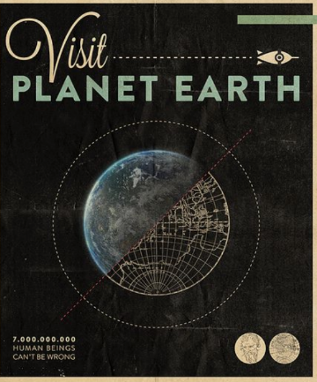
Don’t forget to use the logo….
