Nature painting

This week you challenge is to paint with things you find in nature. Creating wonderful masterpieces using what you find outside. You can use Items found on a nature walk or in the garden like leaves, sticks, grass, flowers, feathers etc.

Things to think about:
- What did you find?
- What type of plant/tree/bird did this come from?
- How could you find out?
- What kind of patterns can you make with the items you found?

You can use the items you find as paintbrushes, or use them to print pattern or even flick paint on to the paper.

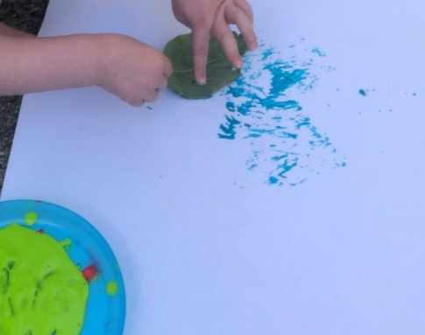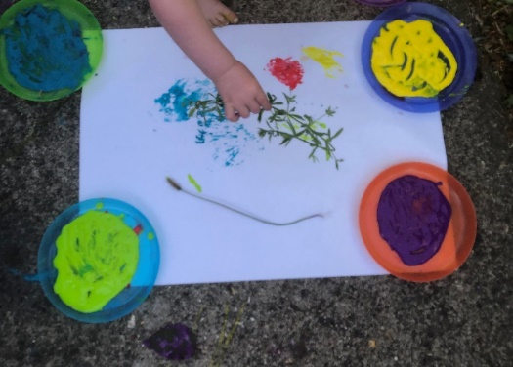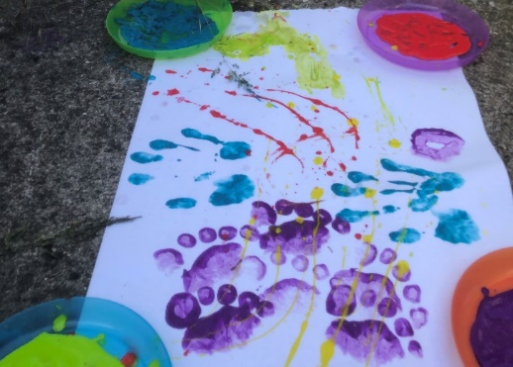
Here are some I did with my son. We used all sorts of things found outside. As it was a sunny day, we did it outside and even added in foot and handprints.

When collecting things make sure:
- A grown up helps collect things that will not hurt or harm like nettles.
- You’re careful not to disturb any animal homes like burrows, hives or nests.
- Don’t collect anything that could belong to someone else or being used by an animal

Fascinating fact: The UK’s woods are home to almost half of all bluebells in the world

