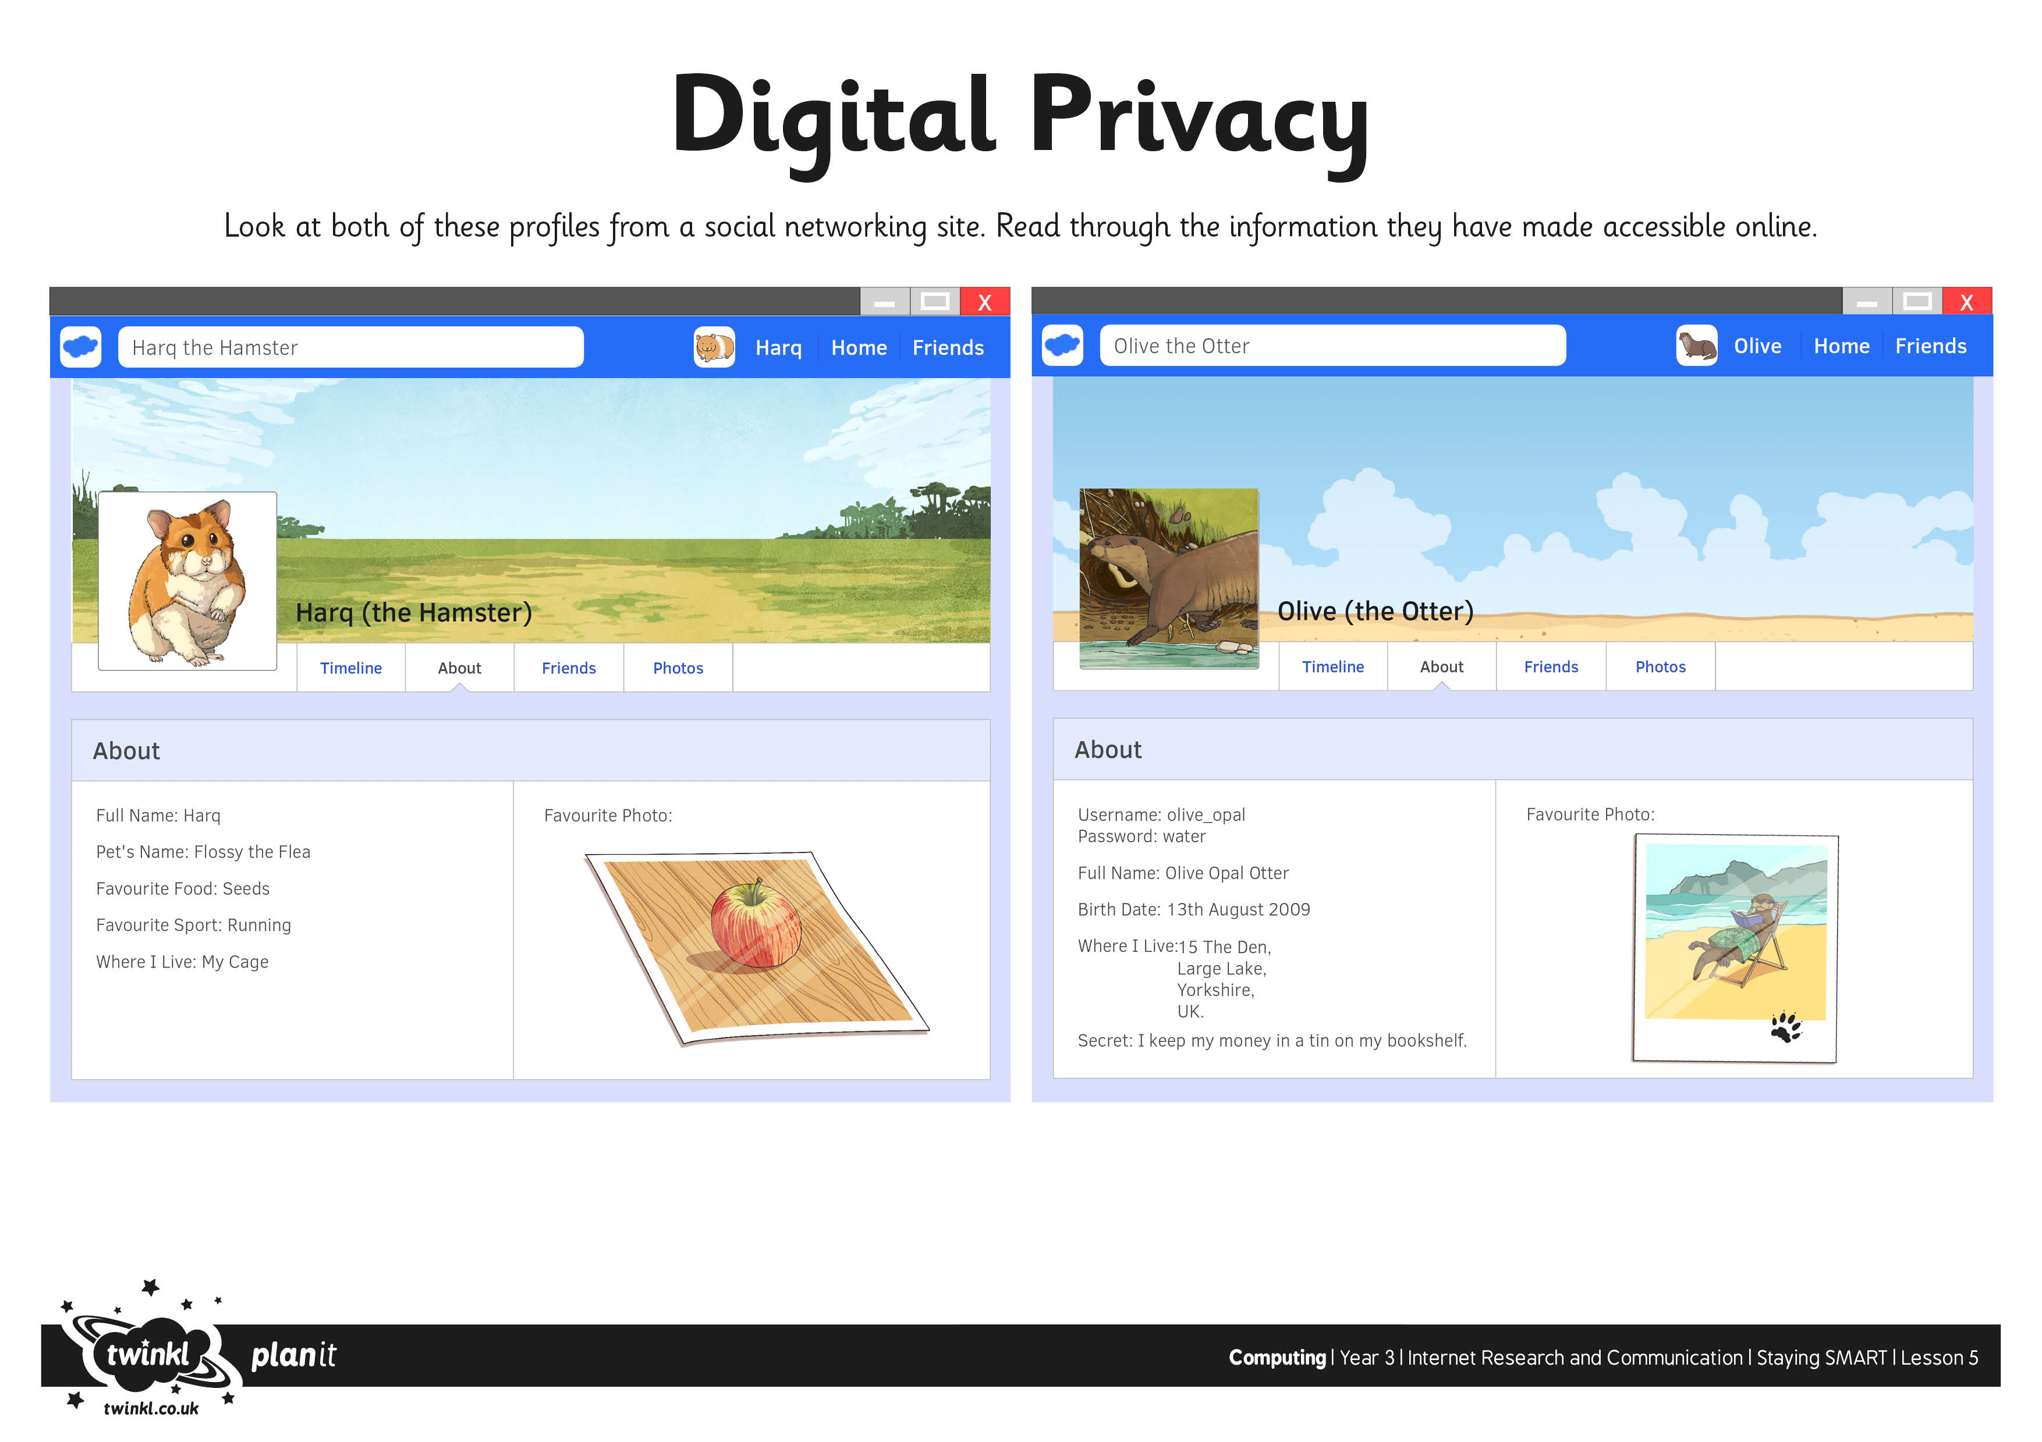
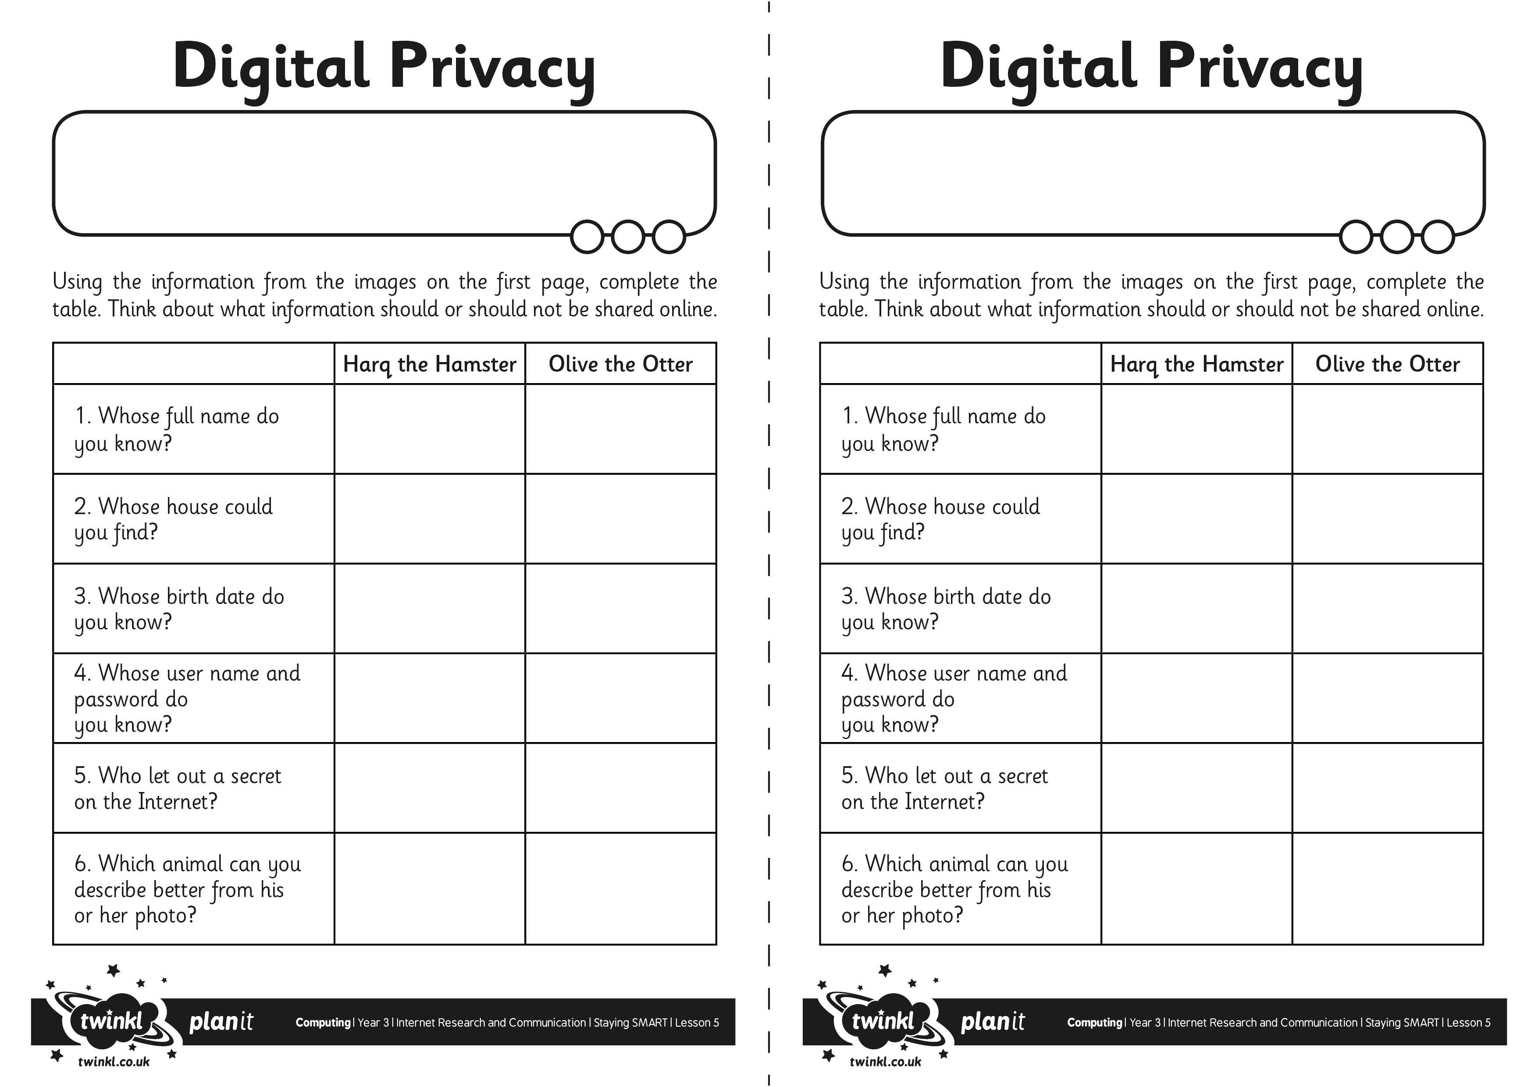
I can explain how to stay safe when communicating online.
I can explain how to stay safe when communicating online.

