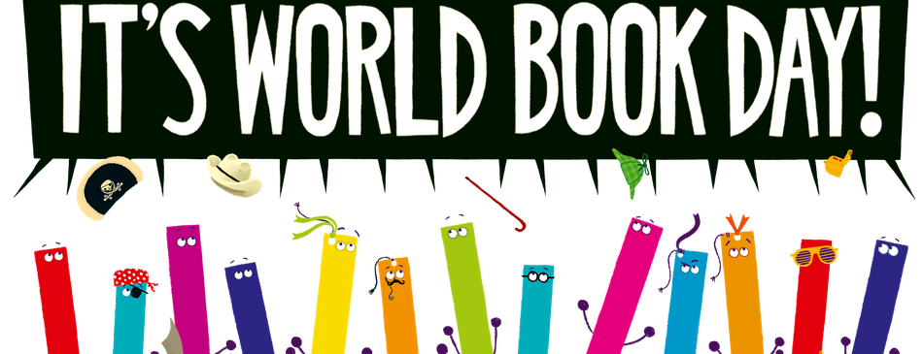
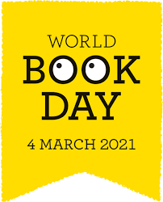

This year we would like to celebrate World Book Day digitally on Thursday 4th March!
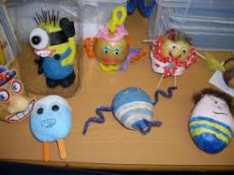
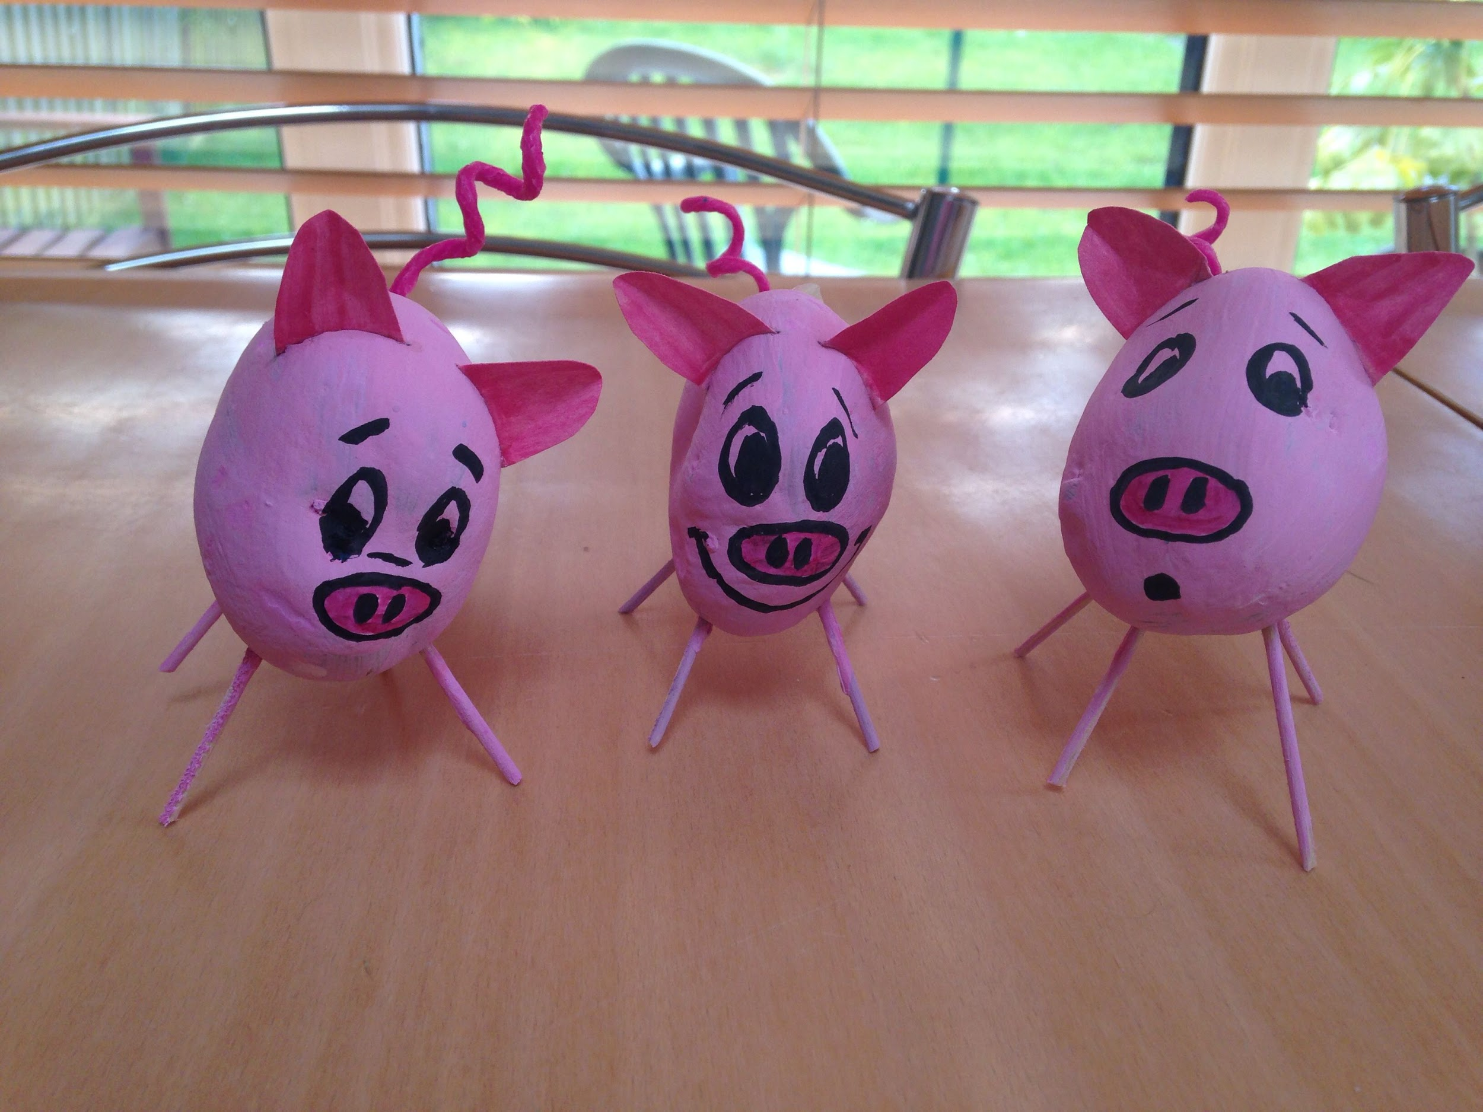
We would like to encourage you to dress up as your favourite book character for the day (as we would do in school).

Another LMPS favourite activity is to create a book character from fruit and vegetables so it would be great to see your efforts this year!

We are planning assemblies on the day to celebrate our love of books, share our character costumes as well as our fruit and veg creations. We will also celebrate together our love of reading through different activities!

Finally, this year World Book Day tokens have gone digital! Please follow this link to access a single-use £1 book token that needs to be used physically in shops and supermarkets: booktoken_PrimaryUK.pdf (worldbookday.com)
Please check with the bookseller prior to spending the token as some retailers are not accepting photos of the tokens.

There are some exciting £1 books available this year: 2021s-1-books (worldbookday.com)

More resources can be found at this website: Share a Story - World Book Day

