|  |
| --- |
| APPLICATION FOR PUPIL LEAVE OF ABSENCE FROM SCHOOL DURING TERM TIME |

|  |
| --- |
| Important Information for Parents  * Head teachers comply with the 2013 amendment to the **Education (Pupil Registration) (England) (2006) Regulations 2013**which means that they cannot authorise a leave of absence from school unless it is exceptional; every case should be treated on an individual basis and with due consideration of the circumstances. Ultimately, it is the Head teacher of the school who decides if a period of leave during term time should be authorised or not * Head teachers may grant leave of absence if they consider exceptional circumstances apply * If the exceptional circumstances are agreed, the Head teacher will determine the length of the absence authorised * Requests for leave of absence should be made in advance and before any arrangements are confirmed or money committed * If leave of absence is granted please contact school to discuss measures to minimise the impact of the absence on your child’s academic progress * This form MUST be completed by the parent who intends to remove the pupil from school during term time * Failure to make a request for a leave of absence in advance will result in the absence taken being recorded as unauthorised   ***Please note: Parents do not have any legal entitlement to take their child on holiday during term time.*** |

|  |
| --- |
| **I wish to apply for Leave of Absence from school to be granted to:**  Full name of child/ren…………………………………………………………………………………………………….......  Address…………………………………………………………………………………………………………………………  ……………………………………………………………………………………………………………………………………  From (1st day of absence) ……………………To (last day of absence) …………………………………………………  Total number of school days………………...Expected date of return to school………………………………………  Reason for proposed absence - please provide reasons to support the application including evidence:  ……………………………………………………………………………………………………………………………………  …………………………………………………………………………………………………………………………………… |
| **Please read the following and sign to indicate you agree:**  *I would like to request the above absence. I understand that the school strongly advises against taking unnecessary absence during term time, and accept that this may have a detrimental impact on my child/ren’s progress. I undertake to make sure my child/ren catch up with any work that is required of them.*  Signature of parent(s)/carer (s)……………………………………………………………………………………  Date: |
| **Your request for leave of absence from school during term time has been considered and has been:****Agreed  Days agreed**…………………………………………………… **Not agreed**  Signature of Headteacher………………………………………………………………… |

Dear Parent/Carer,

**Attendance at school and legal intervention**

[Research](https://www.gov.uk/government/publications/absence-and-attainment-at-key-stages-2-and-4-2013-to-2014) commissioned by the Department for Education shows missing school for even a day can mean a child is less likely to achieve good grades, which can have a damaging effect on their life chances. At Little Melton Primary School our aim is to work with parents to ensure that all our pupils receive the most from their education and reach their full potential.

This letter is to remind all parents/carers regarding the law that requires them to ensure that their child attends school regularly. The Government remains very clear that no child should miss school apart from in exceptional circumstances and schools must continue to take steps to reduce absence to support children’s attainment.

In the DfE policy document entitled, ‘School Attendance: Guidance for maintained schools, academies, independent schools and local authorities’ it states, ‘*Head teachers should not grant leave of absence unless there are exceptional circumstances.* ***The application must be made in advance*** *and the head teacher must be satisfied that there are exceptional circumstances based on the individual facts and circumstances of the case which warrant the leave. Where a leave of absence is granted, the head teacher will determine the number of days a pupil can be away from school.* ***A leave of absence is granted entirely at the head teacher’s discretion’***.

If the school does not receive a request for leave, the head teacher will be unable to consider your individual circumstances and the absence will be recorded as unauthorised. There will be no obligation on the head teacher to reconsider authorising the leave if an application has not been made in advance.

The Local Authority operates a system where any pupil will meet the criteria for legal intervention where they have:

* at least 9 sessions (4.5 school days) lost to unauthorised absence by the pupil during the last 6 school weeks

The intervention could be in the form of a Fixed Penalty Notice. Any pupil at Little Melton Primary School who meets the criteria, will be referred to the Local Authority for action to be considered.

If a Fixed Penalty Notice is issued the arrangement for the payment will be detailed on the Penalty Notice. The penalty is £60 if paid within 21 days of receipt of the notice, rising to £120 if paid after 21 days but within 28 days of the receipt of the Notice. The Fixed Penalty Notice is per parent per child. You should be aware that failure to pay the total amount within the timescale will result in legal action being taken.

I hope we can count on your support in this matter, please do not hesitate to contact me if you have any questions.

Yours faithfully

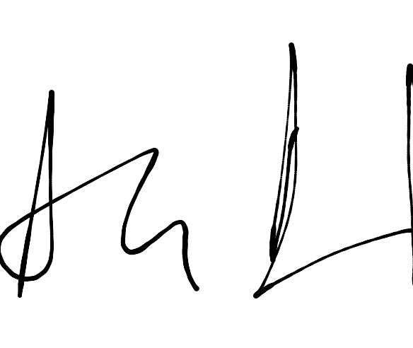

Mr A Pritchard

Headteacher