Tuesday 25.01.22 - L.O. To use a number-line for division

There are 20 books in total and they are packed in boxes of 10. How many boxes are there?

÷ =

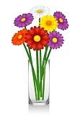
8 flowers are shared between 2 vases. How many flowers go in each vase?

÷ =

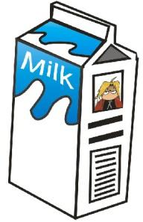
The shopkeeper has 15 bottles of milk, if she delivers 5 bottles to each house, how many houses will she deliver to?

÷ =

Challenge:
(Top Tip! There may be some left over)

There are 16 children in Emerald class, and 5 tables for the children to work on. How many children can fit on each table?

÷ =

