
P.E.
Invasion Games (Coach when available)
Music
Famous Composers (1)
Orchestras and choirs (2)
Use examples of correct musical language
English/Big Write:
TEXT: Spy School (main)
TEXT: London Eye (support)
TEXT: Daisy 006 and a bit/My hamster is a spy (SEN)
Christmas TEXT: A Christmas Carol (Marcia Williams and 2001 movie)
Grammar & Punctuation:
Descriptive writing
Instructional writing
Spelling: Purple Mash
Handwriting: Nelson Scheme

* content of Topic will vary, different subjects may be taught discretely.
Eagle Owls Year Group: 5/6 Autumn term 2023 Year B
Technical World
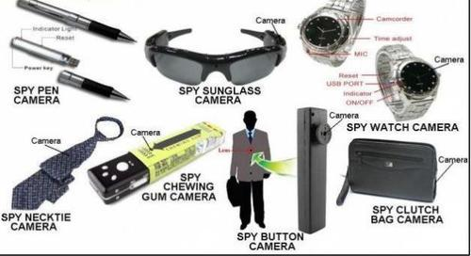

Art & Design
Food Technology – cooking over the decades (link with Topic)
Christmas cards with electrical circuits
Computing/PHSE
1)E-safety 2) Keeping safe and managing risk
Research
Doc (Google Drive)
Coding/Programming
Online safety and understanding
Humanities TOPIC (History)
Changes in Leisure and Entertainment in the 20th Century
Mathematics:
Four operations
10 100 1000
Place Value
Roman Numerals
Word Problems

Science: (Curriculum enrichment Light lessons at NHS)
Light (1)
Electricity (2)
Simple circuits, voltage, circuit diagrams.

R.E.
Islam (1)
Hinduism (2)

